English Literature: Component 2, Section C
Unseen Poetry
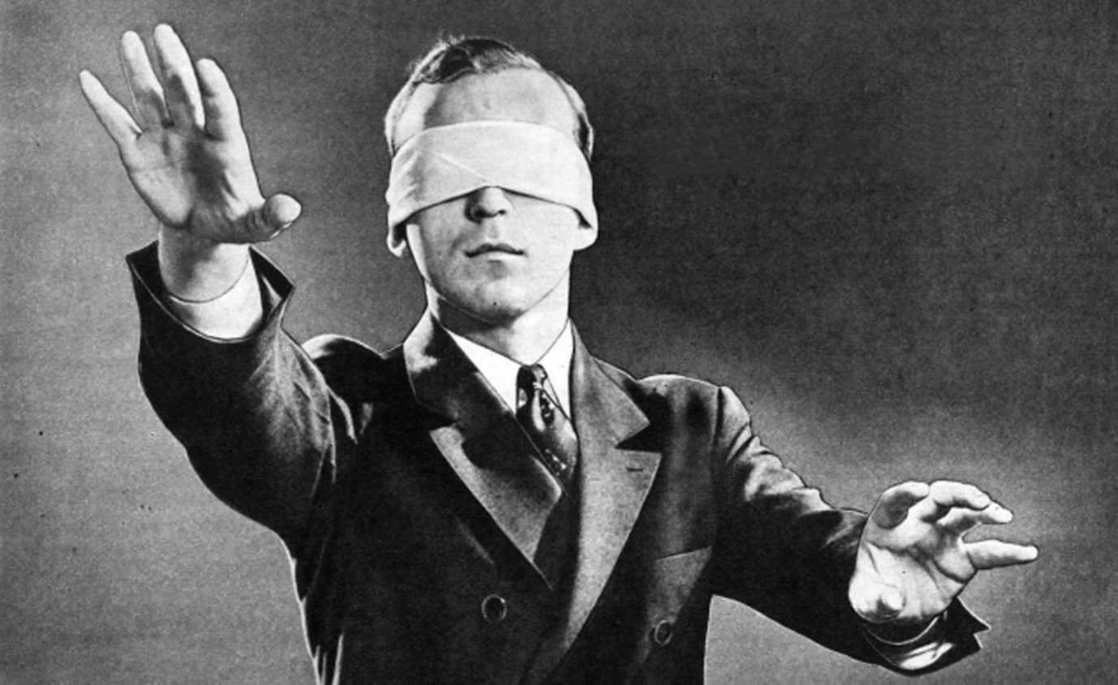

DATE OF EXAM:

1 hour. 40 marks.
Part (a) = 15 marks
Part (b) = 25 marks
Name:
Class:
Teacher:

You will have to answer two questions about the unseen poems:

- Question 1 is worth 15 marks and will ask you to analyse one poem. Your answer should cover:
- What the poem is about-the poem’s message, themes and ideas.
- How the poet uses form, structure and language to communicate these ideas.
- For Question 2 you’ll have to compare both poems. This question is worth 25 marks.
- You should write about similarities and differences between the two poems. Your answer to this question must focus on the techniques the poets use, such as form, structure, and language.
- Question 2 is worth a lot more marks than Question 1, so in the exam make sure you spend 20 minutes on Question 1 and 40 minutes on Question 2.

Read the two poems, A Gull by Edwin Morgan and Considering the Snail by Tom Gunn. In both of these poems the poets write about the effects animals have on people.

(a) Write about the poem A Gull by Edwin Morgan, and its effect on you. [15]

You may wish to consider:
• what the poem is about and how it is organised;
• the ideas the poet may have wanted us to think about;
• the poet’s choice of words, phrases and images and the effects they create;
• how you respond to the poem. [15 marks]

TASK
Below are two sample answers to part (a). Complete the following activities for each one:
- Write down the band that you think the answer falls into (Band 3, 4 or 5)
- Give at least two reasons why you awarded this grade
Sample Response 1

Firstly, “A Gull” is a poem by Edwin Morgan and it is written a from first person point of view. The voice of the poem suggests that we, as humans, underestimate a seagull and that we are not clear of its true intentions. Moreover, in the second line it becomes clear to us that the poem attempts to personify the bird. He does this by stating that the seagull is just standing there on his “window ledge” and he says “nothing” as if the poet expected the gull to talk. Perhaps some kind of explanation as to why the gull is invading his privacy by having a “good look inside” of his window. Furthermore, the poet uses certain words to emphasise a sense of feeling threatened by this gull. Morgan uses words such as “icebergs” and “cold inspection” to emphasise how uncomfortable he feels, knowing that the bird is still there. This is emphasised even further when the poet says that “there was not a fish in the house – only me” as if the narrator was describing himself as prey and almost like the gull was there to hunt him.4 Even more so, this poem becomes even more interesting when the narrator starts talking to the gull, “I tell you my chick” as if the narrator knows the bird and therefore tries to communicate with it. Also, the use of that speech suggests as though the narrator was inside the mind of the gull and could tell that it wanted to eat something. This is ironic as it refers the narrator to being like the bird in the same way that the narrator tries to personify the bird.

Nonetheless, we begin to feel as though the narrator admires the gull as the poem progresses. By describing the bird as having a “tight firm forward body” it further emphasises the attempt to personify the bird.

Alternatively, towards the end of the poem it would appear as though the narrator becomes somewhat scared of the gull. This is clearly shown when he describes the bird as being a “thing” as though it was no longer a seagull but something else. Therefore, by using the words “scuttered claws” which would create a sense of abnormality especially considering the bird is now being described as a “thing.”

Furthermore, it is evident that a sense of danger is brought to mind at the end of the poem considering the narrator asks “who would be next” as if he was not the only victim of this “thing.” He then goes on to asking whether or not the next victim would be “ready” for this encounter. Moreover, it is as if the reader feels as though the bird is purposely trying to bring fear upon him by glaring into the window. Also, the way the poet describes the bird as a “supergull” it seems that Morgan was trying to promote the idea of there being more than meets the eye and although it would seem as though the gull is inferior to humans, the poem suggests that animals in general should not be underestimated.
Sample Answer 2

The first poem, 'A Gull', is about a man who is visited by a seagull which “stood on my window ledge today.” Just from this first line, we can see that the narrator in the poem is speaking in the first person, evident from the word “my.” Along with “my”, the word “today” creates a sense of immediacy and makes it easier for us, the readers, to visualise the situation.

As the poem continues, we could say that the narrator becomes paranoid about the seagull which is sitting on his window ledge. There is hints of this in the words, “that was a cold inspection, I can tell you” and “there was not a fish in the house – only me.” By describing the seagull as judgemental, it appears that the narrator is becoming increasingly worried by the seagull’s actions. It is as though the narrator sees himself as prey to the seagull.

From the way the narrator speaks about the seagull, it becomes increasingly clear that he is unnerved by the presence of the bird. This is clear when he says, “That was a cold inspection I can tell you.” The narrator is obviously worried about the bird and in an attempt to protect himself, he aggrandises the seagull, by calling it “that white one.” This name gives the seagull an image of power over the narrator. Just this reference alone shows how much the narrator is worried by the creature, and it is as if he is bigging up the bird to make it leave him alone, when in all reality, it is just a seagull.

b) Now compare A Gull by Edwin Morgan and Considering the Snail by Tom Gunn. [25]

You should compare:
• what the poems are about and how they are organised;
• the ideas the poets may have wanted us to think about;
• the poets’ choice of words, phrases and images and the effects they create;
• how you respond to the poems.

TASK
Below are two sample answers to part (b). Complete the following activities for each one:
- Write down the band that you think the answer falls into (Band 3, 4, or 5)
- Give at least two reasons why you awarded this grade
CHALLENGE: Add a paragraph making one more comparison between the poems.

Sample Response 1

The poem called “Considering the Snail” by Thom Gunn is also similar to “A Gull” in the way that both poems seem to suggest that animals should not be underestimated. This is evident when the snail is described as being a hunter, “as he hunts”, which of course is ironic as they are not seen as being harmful and considering they are herbivores and they do not eat meat, then surely they are not hunters. However, this just further emphasises how snails are underestimated perhaps because of their size or their speed of movement. Furthermore, a sense of irony is once again created when the slime a snail leaves behind is described in the poem as being a “bright path” which relates to a point that was made about “a gull” known as the expression, there is more than meets the eye. Similarly, the narrator questions “what power is at work” which relates to the snail being more than just a snail in the same way the gull was described as a “supergull.” Also, both narrators of the poems speak of their animals in a way that would suggest that they are both fascinated by them.

Even more so, both animals in both of the poems seem to be searching for food as the snail is travelling through a “green night” and the gull is told that there is “food everywhere:” which would suggest this. Also, both poems speak of the animals in first person.

To conclude, both poems create an essence that animals should be appreciated for what they are and that they should not be underestimated. “Considering the Snail” is about appreciating the snail instead of the usual idea of seeing it as being disgusting. “A Gull” is about how the gull should not be underestimated and that there is more to an animal than what would first seem to appear.

Sample Answer 2

The second poem, “Considering the Snail” by Thom Gunn, is similar to “A Gull” in the fact that both poems are clearly describing an animal, and have no clear subtext. This is evident in the fact that both poems start with the name of the animal, “The Snail” and “A Seagull” respectively. By naming the subject in the very first line of each of the poems, the authors have made it very clear what the subject of the poems are, and there can be no confusion as to what the poems are about.

Furthermore, in Gunn’s poem we can see how the conditions in the poem are making life hard for the snail. This can be seen when the narrator says, “the grass is heavy” and “darkened the earth’s dark.” From these short phrases, the author could be trying to emphasise how hard the life of a snail is, or he could be describing the difficulties of this particular journey for the snail. This is a contrast to the life of the seagull in 'A Gull', where the author makes it sound as though the bird has an easy life of power and intimidation over others.

The two poems are also different in the way that they describe the animals‘ positions of power. For example, we are told that the snail has “pale antlers”, whereas the seagull could be “a supergull” with “scuttered claws.” The fact that the snail has antlers suggests that it is prey to others, in contrast to the seagull’s description, which tells us that the bird is fierce and powerful, the opposite to how the snail is portrayed.

Read the two poems, Eating Poetry by Mark Strand and Volumes by Joe Shapcott. In both of these poems the poets write about their strong feelings towards reading.

(a) Write about the poem Eating Poetry by Mark Strand, and its effect on you. [15]

You may wish to consider:
• what the poem is about and how it is organised;
• the ideas the poet may have wanted us to think about;
• the poet’s choice of words, phrases and images and the effects they create;
• how you respond to the poem.

Eating Poetry

Ink runs from the corners of my mouth.
There is no happiness like mine.
I have been eating poetry.
The librarian does not believe what she sees.
Her eyes are sad
and she walks with her hands in her dress.
The poems are gone.
The light is dim.
The dogs are on the basement stairs and coming up.
Their eyeballs roll,
their blond legs burn like brush.
The poor librarian begins to stamp her feet and weep.
She does not understand.
When I get on my knees and lick her hand,
she screams.
I am a new man.
I snarl at her and bark.
I romp with joy in the bookish dark.

Mark Strand

b) Now compare Eating Poetry by Mark Strand and Volumes by Joe Shapcott. [25]

You should compare:
• what the poems are about and how they are organised;
• the ideas the poets may have wanted us to think about;
• the poets’ choice of words, phrases and images and the effects they create;
• how you respond to the poems.

Volumes

They put me in a fever. It’s not enough
to look. I want to hold them all
and stuff them in the gaps in my head.
I gallop past Health towards Travel
where I break into a muck sweat
as I lift and sniff a book about Verona.
The odour makes me stagger and long
to be a book mite, to live right inside
and gulp holes through the picture maps.
I don’t trust myself in Fiction. The thought
of those thousands and thousands of stories-
the crush and babble of other minds-
makes the whites of my eyes show and roll.
Last time I sauntered by those shelves
I slammed into the New Titles display
and crashed right through a pyramid of books
on to my back among the toppled photos
of authors winking at the carry on.
I got a cuppa and a pat on the rump
from the kid saleslady who has the bubble
of book hysteria herself, I’d guess.
If she could, she’d wear print on her skin.
There are words written for everything,
I think, and it’s only a matter of time
before I find a new ‘How To’ book:
how to stand upright, how not to fall
and how not to cry out when you do.

Jo Shapcott

Read the two poems, Woman Work by Maya Angelou and I Had Rather Be A Woman by Daphne Schille. In both of these poems the poets write about their lives and daily routines.

(a) Write about the poem Woman Work by Maya Angelou, and its effect on you. [15]

You may wish to consider:
• what the poem is about and how it is organised;
• the ideas the poet may have wanted us to think about;
• the poet’s choice of words, phrases and images and the effects they create;
• how you respond to the poem. [15 marks]

b) Now compare Woman Work by Maya Angelou and I Had Rather Be A Woman by Daphne Schille. [25]

You should compare:
• what the poems are about and how they are organised;
• the ideas the poets may have wanted us to think about;
• the poets’ choice of words, phrases and images and the effects they create;
• how you respond to the poems.

Read the two poems, Handbag by Ruth Fainlight and Jumper by Tony Harrison. In both of these poems the poets write about their feelings towards their mother.

(a) Write about the poem Handbag by Ruth Fainlight, and its effect on you. [15]

You may wish to consider:
• what the poem is about and how it is organised;
• the ideas the poet may have wanted us to think about;
• the poet’s choice of words, phrases and images and the effects they create;
• how you respond to the poem. [15 marks]

Handbag

My mother’s old leather handbag,
Crowded with letters she carried
all through the war. The smell
of my mother’s handbag: mints
and lipstick and Coty powder.
The look of those letters, softened
And worn at the edges, opened,
read, and refolded so often.
Letters from my father. Odour
of leather and powder, which ever
since then has meant womanliness,
and love, and anguish, and war.

Ruth Fainlight

b) Now compare Handbag by Ruth Fainlight and Jumper by Tony Harrison. [25]

You should compare:
• what the poems are about and how they are organised;
• the ideas the poets may have wanted us to think about;
• the poets’ choice of words, phrases and images and the effects they create;
• how you respond to the poems.

Jumper

When I want some sort of human metronome
to beat calm celebration out of fear
like that when German bombs fell around our home
it’s my mother’s needles, knitting, that I hear,
the click of needles steady, though the walls shake,
The stitches, plain or purl, were never dropped.
Bombs fell that night until daybreak
but, not for a moment, did the knitting stop.
Though we were shivered in the cellar-shelter’s cold
and the whistling bombs sent shivers through the walls
I know now why she made her scared child hold
the skeins she wound so calmly into balls.

We open presents wrapped before she died.
With that same composure shown in that attack
she’d known the time to lay her wools aside-

the jumper I open’s shop-bought, and is black!

Tony Harrison

Read the two poems, Kissing by Fleur Adcock and Rubbish at Adultry by Sophie Hannah. In both of these poems the poets write about intimate relationships.

(a) Write about the poem Kissing by Fleur Adcock, and its effect on you. [15]

You may wish to consider:
• what the poem is about and how it is organised;
• the ideas the poet may have wanted us to think about;
• the poet’s choice of words, phrases and images and the effects they create;
• how you respond to the poem. [15 marks]

b) Now compare Kissing by Fleur Adcock and Rubbish at Adultry by Sophie Hannah. [25]

You should compare:
• what the poems are about and how they are organised;
• the ideas the poets may have wanted us to think about;
• the poets’ choice of words, phrases and images and the effects they create;
• how you respond to the poems.

Read the two poems, The Family by Jenny Fromer and ‘Sunday Afternoon…’ by Robert Brush. In both of these poems the poets write about attitudes to the older generation.

(a) Write about the poem The Family by Jenny Fromer, and its effect on you. [15]

You may wish to consider:
• what the poem is about and how it is organised;
• the ideas the poet may have wanted us to think about;
• the poet’s choice of words, phrases and images and the effects they create;
• how you respond to the poem. [15 marks]

The Family

She arrives home with a problem,
Needing time to think.
Mother and father, grey and old,
Kiss her.
She walks in,
Expensive clothes
Strong odour of French perfume
Whilst the parents cling to their drab grey world
And tired apartment.
The parents, grateful for the time she’s given them,
Forget when all their time was hers,
No appreciation for their used-up bodies
Given away for her.
She may realise there is no reason to feel guilty,
But she just doesn’t have the time.
The people who gave her all their time and energy
Have become a butt for her jokes.
She meant to phone, but…
Or write, only…
But anyhow, she’s home now,
So what’s the difference?
They’re only her parents
But she outgrew them long ago;
She outgrew them,
So why does she need to make excuses?
Because she loves them,
and after all, they are her parents…

Jenny Fromer

b) Now compare The Family by Jenny Fromer and ‘Sunday Afternoon…’ by Robert Brush. [25]

You should compare:
• what the poems are about and how they are organised;
• the ideas the poets may have wanted us to think about;
• the poets’ choice of words, phrases and images and the effects they create;
• how you respond to the poems.

Sunday Afternoon in the Lounge of
an Old People’s Home and
Monday Morning in Class with 4X

Alf and Stanley, Exploding bubble gum
Charlie and Flo, Hooking out bogeys,
Maud and Eliza, Don’t give a toss
Betty and Joe For yesterday’s fogeys.
Sit in a circle But Jason, Gary,
Smelling of age Tracey and Dawn,
Muttering, mumbling, It’s for you they’re keeping
Chewing on rage. Those lounge seats warm.

Robert Bush

Read the two poems, The Closed School by Raymond Wilson and ‘After Lessons’ by Steven Knight. In both of these poems the poets write about being inside an empty school.

(a) Write about the poem The Closed School by Raymond Wilson, and its effect on you. [15]

You may wish to consider:
• what the poem is about and how it is organised;
• the ideas the poet may have wanted us to think about;
• the poet’s choice of words, phrases and images and the effects they create;
• how you respond to the poem. [15 marks]

b) Now compare The Closed School by Raymond Wilson and ‘After Lessons’ by Steven Knight. [25]

You should compare:
• what the poems are about and how they are organised;
• the ideas the poets may have wanted us to think about;
• the poets’ choice of words, phrases and images and the effects they create;
• how you respond to the poems.

Read the two poems, Winter by Gareth Owen and Frost by Robert Hull. In both of these poems the poets write about cold weather in different ways.

(a) Write about the poem Winter by Gareth Owen, and its effect on you. [15]

You may wish to consider:
• what the poem is about and how it is organised;
• the ideas the poet may have wanted us to think about;
• the poet’s choice of words, phrases and images and the effects they create;
• how you respond to the poem. [15 marks]

b) Now compare Winter by Gareth Owen and Frost by Robert Hull. [25]

You should compare:
• what the poems are about and how they are organised;
• the ideas the poets may have wanted us to think about;
• the poets’ choice of words, phrases and images and the effects they create;
• how you respond to the poems.

Enjambment | The continuation of a sentence or clause over a line-break.  In other words the sentence runs on over two lines.
Metre | The metre of a poem is the underlying structure (can relate to the number/duration of syllables)
Stanza | A grouped set of lines within a poem.
Refrain | A line or stanza in a poem that is repeated.
Rhyming Couplet | A pair of lines of metre in poetry. They usually comprise two lines that rhyme and have the same metre.
Blank verse | A poem with no rhyme scheme but which often uses iambic pentameter.
Free verse | An open form of poetry with no rhyme scheme or meter patterns.
Elegy | A mournful, melancholic poem. Usually a funeral song or a lament (passionate expression of grief) for the dead.
Metaphor | A figure of comparing to unlike things without using like or as. Something IS something else.
Simile | Making a comparison using the words ‘like’ or ‘as’
Juxtaposition | When a poet puts two ideas, events, characters or descriptions close to each other to encourage the reader to contrast them. E.g. the excited narrator and the terrified librarian in Eating Poetry
Oxymoron | A figure of speech in which apparently contradictory terms appear in conjunction (e.g. same difference)
Personification | Giving an object human qualities.
Onomatopoeia | Sound words (e.g. Bang!)
Semantic/lexical field | A set of words grouped by meaning referring to a specific subject (e.g. red, black, green, yellow are all colour words)
Anaphora | The repetition of words or phrases at the beginning of lines in poetry.
Sibilance | The repetition of a ‘hissing’ sound in lines of poetry. ‘She dusts the house, I sweep’
Imagery | The formation of mental images, figures or likenesses of things. It includes metaphors, similes and personification.
Alliteration | The repetition of the same sounds at the beginning of words in a sentence.
Analogy | Making a comparison to show similarities.
Assonance | Rhyming vowel sounds, repetition of vowel sounds.
Hyperbole | Extravagant exaggeration.
Tone | The general atmosphere of a poem or story and the effect that it has on readers.
Symbolism | A device in literature where an object represents an idea.
Caesura | A pause in a line, e.g. after the word ‘dropped’ in ‘He dropped – more sullenly than wearily.’
Consonance | Repetition of a consonant sound in nearby words, e.g. ‘silent, to village wells’
End-stopping | Finishing a line of poetry with the end of a phrase or sentence.
Half-rhymes | Words that have a similar, but not identical, end sound. E.g. ‘shade’ and ‘said’
Iambic pentameter | Poetry with a metre of ten syllables – five of them stressed, and five unstressed. E.g. ‘when you are old and grey and full of sleep’
Iambic tetrameter | Like iambic pentameter but with a metre of eight syllables, four stressed and four unstressed. E.g. ‘I know that I shall meet my fate’
Internal rhyme | When two words in the same line rhyme, e.g. ‘it is underneath the coppice on the heath’
Irony | When words are used in a sarcastic or comic way to imply the opposite of what they normally mean. It can also mean when there is a difference between what people expect and what actually happens.
Petrarchan Sonnet | A form of sonnet in which the first eight lines have a regular ABBA rhyme scheme and introduce a problem, while the final six lines have a different rhyme scheme and solve the problem.
Plosive | A short burst of sound made when you say a word containing the letters, b,d,g,k,p,t.
Sonnet | A form of poem with fourteen lines that usually follows a clear rhyme scheme. Sonnets are often used for love poetry.
Syntax | The arrangement of words in a sentence or phrase so that they make sense.
Volta | A turning point in the poem, when the argument or tone changes dramatically.

Mark Schemes
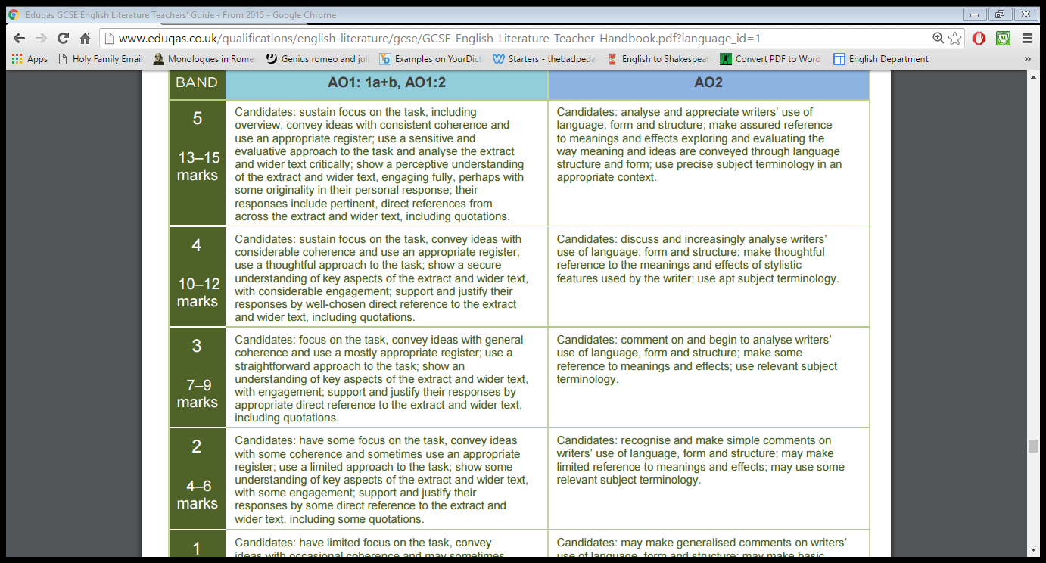
Part (a)

Part (b)

