English Language

Component 1
Name:
Class:
Teacher:
DATE OF EXAM:
1 hour 45 minutes.

How should I use this guide?

The booklet is designed to recap on key learning from your English lessons, in order to ensure you achieve the best possible mark in your GCSE English Language Component 1 exam. It is organised into sections to help you understand each of the questions on the exam paper. The aim of this revision booklet is to guide you through exactly how to answer each type of question.

Once you’ve learnt the way to each question, have a go at some of the practice papers at the back. The more you practice, the better you will be.

It is recommended that you start at the beginning of the booklet and work your way through each of the sections. Remember, this guide will only help you if you complete the past papers!
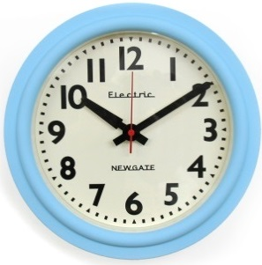
You should ensure that you are regularly completing the practice tasks in timed conditions. Use your mobile phone to set a timer or ask someone at home to tell you when your time is up.

Your English teacher will be happy to give you feedback on any responses you complete.

What will the exam look like?
The exam will be 1 hour 45 minutes long. You should spend the FIRST HOUR on the READING section of the paper, and then give yourself a FULL 45 MINUTES for the WRITING section. Time management is very important if you are going to collect as many marks as you can, so keep an eye on the clock, or wear a watch and time yourself!

READING SECTION – 40 MARKS (1 HOUR)
20th Century Literature Reading
You will be given an extract from a 20th century prose text and a series of questions to answer. As the exam is worth 40 marks, each 10 mark question should take you 15 minutes. Again, manage your time carefully here!

WRITING SECTION – 40 MARKS (45 MINUTES)
Creative Prose Writing
In this section you will be assessed for the quality of your creative prose writing skills. 24 marks are awarded for communication and organisation; 16 marks are awarded for vocabulary, sentence structure, spelling and punctuation. You should aim to write about 450-600 words.
SECTION A: READING

Spend ONE hour on this section. Read the questions first and then look at the text to find the evidence to help you build an answer. As a handy guide, a 10 mark question should take you 15 minutes in total.
So, let’s have a look at a past paper and how to answer each of the questions.

That’s what the paper will look like. Let’s now look at how to answer each question in turn.

A1
Read lines 1-9.
A1. List five reasons why Obed Ramotswe went to South Africa. [5]
Look at what it tells you to do here. LIST. Don’t write a paragraph, that will be a waste of time and will annoy the examiner as it will show that you haven’t read the question. If it says list, then LIST!
Examiner’s advice:
- Read really carefully what lines it tells you to focus on and make sure you only take information from these lines. In this case, only lines 1-9
- Pick out five phrases from the extract – you don’t need to show any analysis.
- You must separate your ideas by writing each idea out as a different bullet point – if you put more than one idea in the same sentence, you will only be credited for one.
Let’s have a look at a real pupil’s answer. How well did they do?

As you can see, this pupil only received 4 marks out of a possible 5. Why? Well, firstly, they made it hard for themselves by writing a paragraph. They didn’t need to do this and should have just listed. Secondly, they didn’t find five reasons.
Now it’s your turn. Improve on their answer and make sure you get 5 out of 5.
List five reasons why Obed Ramotswe went to South Africa.

A2
Read lines 10-17
A2. How does the writer show what Obed went through to become a miner? [5]
This is a HOW question. It’s usually easy to spot a HOW question, as it begins with the word ‘How’! Historically, students across the country don’t do well at these questions, but they’re not as difficult as some people fear. If you follow a simple system, you should be able to pick up lots of marks on these questions.
Examiner’s advice
- Read really carefully what lines it tells you to focus on and make sure you only take information from these lines. In this case, only lines 10-17.
- You can use the sentence starter, ‘The writer shows…’, but not on every sentence (it gets boring!). This will ensure your focus is on the writer and not your own ideas.
- Open your paragraph with an overall sentence about how the writer shows what the question is asking.
- Then provide 4-5 examples to support this and explore how these ideas are shown. Do this by looking at word level and then zoom out – consider whether the tone changes in the extract. Explore the effect on the reader.

Let’s have a look at a range of real answers for this question. How well did they do?

This answer seems detailed, but it only got 2 out of a possible 5. Why? Well, read it. It starts well but then tries to be too clever with the reference to “syndetic listing”, which isn’t very well explained. Much better to be simple and clear (see the next response!). The rest of the answer lacks a focus and doesn’t zoom in on 4 or 5 specific details.

But let’s look at how the next one did…

The answer above isn’t perfect, but it does score a full 5 out of 5. Why? Because the student KNEW WHAT THE EXAMINER WANTED.
Notice how the student kept the answer really focused on the question, included 4 or 5 specific examples and then focused on the HOW, whether it be listing, repetition, statements or structure. They then tell the examiner the effect on the reader.

Have a go yourself. Don’t just copy the one above. Write your own!

How does the writer show what Obed went through to become a miner?

A3
Read lines 18-30
A3. What impressions do you get of the work in the mines from these lines? [10]
This question is asking you what impressions the writer gives. Don’t get carried away with your own opinion – keep it focused on the text!
Examiner’s advice:
- Read really carefully what lines it tells you to focus on and make sure you only take information from these lines. In this case, only lines 18-30.
- Draw a box around the section you are looking at and track it carefully – explore the lexical fields (patterns of words) use to spot any changes at word level.
- Again, you can use the sentence starter, ‘The writer creates the impression that…’ This will ensure your focus is on the writer and not your own ideas.
- Write an overview for your first sentence of how the idea is shown and try to make it conceptual. Eg. For the Obed extract you could say, “To gain an impression that the workers are dehumanised, the writer…” or “The workers are treated inhumanely as shown when the writer states…”
- Select 4-5 quotes to zoom in on – identify techniques and explore the effect.
- Consider the tone of the extract.
- Use some specialist terminology to gain full marks eg. adverbs, superlatives.
- Explore the changes in tone and consider how the writer changes this to influence the reader.
Let’s have a look at a range of real answers for this question. How well did they do?
This candidate wrote quite a lot, but only got 6 marks out of 10. That’s a solid mark, but how could they have done better?
Well, when you read it you should notice that there are some good points but also some points that aren’t very well explained (eg. “I also get the impression that the job required intelligence and concentration. “they taught us Funagalo”). This means that the candidate is going to struggle to get 7 or more out of 10.
Let’s have a look at another:
The first thing to notice here is how succinct (short and focused) this answer is. It doesn’t go on for ever and ever, and yet it gets 9 (possibly 10!) marks out of 10. How does it manage that?
Well, when you read it, you can see how the answer covers a range of impressions and focuses in detail on specific, well-chosen quotations from the text. The candidate also uses a final sentence giving a sense of overview, which is needed for a top band answer. As a tip, if you can, get your overall sentence in first, as it will tell the examiner that you are focused on getting top marks. If your sense of the ‘overall’ isn’t clear till the end of your answer, make sure you don’t forget to write it down before moving on.

Now have a go yourself. Make it your own, don’t just copy the one above. Keep it focused and make sure you give that overview, either at the beginning or the end!
What impressions do you get of the work in the mines from these lines? [10]

A4
Read lines 31-46.
A4. How does the writer make these lines tense and dramatic? [10]
You should write about:
- what happens to build tension and drama;
- the writer’s use of language to create tension and drama;
- the effects on the reader.
Clear this is another HOW question. Except this time, it’s worth a full 10 marks. It’s important that we get this right, then!
- Read really carefully what lines it tells you to focus on and make sure you only take information from these lines. In this case only lines 31-46.
- Use the sentence starter, ‘The writer shows…’ This will ensure your focus is on the writer and not your own ideas.
- The question is not that interested in your own opinion (sorry!) but, again, wants to know how different ideas are shown in the text (AO2 – language analysis).
- It is quite similar to question A3. In fact, you can read the question as: “How does the writer create the impression…?” to ensure you remain focused on the writer’s intentions.

Look over the page for some real-life example answers. How well did they do?

This answer only scored 3 out of a possible 10. If you read it, you can see that the student spotted lots of things that created tension, but they haven’t really explained them very well. There are also bits that clearly don’t make sense (such as the man being thrown into the hole being an ‘accident’!). The examiner has taken this as a lack of understanding, so it’s a good reminder to read the section carefully before you write your answer!

Let’s have a look at another…

Now this is how you do it. Every sentence is really clear and focuses on a different technique the writer uses to create tension. Quotes are well-chosen and points are well-explained. The student also knew that the examiner was looking for an ‘overall’ sentence to show that they understood the whole extract. The result? A very happy examiner and full marks for the student.

Have a go yourself in the box on the opposite page.

A5

The most important thing that you need to do on this question is GIVE YOURSELF TIME TO DO IT! That means managing your time carefully on the rest of the section. Don’t go over 15 minutes for every 10-mark question.
- This question will sometimes require you to consider the whole passage. In this case, we are just looking at lines 47 to the end.
- Sometimes the question will use the term ‘evaluate’. This means it wants you to explore how the writer has made you feel a personal response. Eg. If you feel sorry for Obed, how has the writer created that impression? If you do this, you will be exploring both bullet points.
- Try to look in detail at the character/situation and avoid picking out really obvious ideas – consider nuances in their character/situation.
- Consider how the tone of the passage has an impact on how you feel towards the character/situation.

Ok, let’s see how some students got on…
This answer makes some valid points but only scores 4 out of a possible 10. If you read it, you can see why. It lacks a bit of focus at times and it is not always clear that the candidate is answering the question. They have pulled out some good quotations, but they don’t really explain them very well. This candidate could have done much better.
Let’s have a look at another…
This is MUCH better. Again, you can tell the candidate knows what the examiner wants. Every sentence makes a clear point, backs it up with evidence and answers the question. They also finish with their ‘overall’ sentence, to ensure they get into the top band and achieve highly. It’s not perfect, but it’s close!

Have a go at A5 yourself!

Practice Papers
In the next section of the booklet you will find lots of practice papers. You can sit whole papers, or focus on one type of question at a time.
For example, you might choose to do all of the HOW questions because you’re worried that they’re your weakness.
However you use them, USE THEM. Your teacher will be happy to have a look at your responses and give you feedback on how to improve.
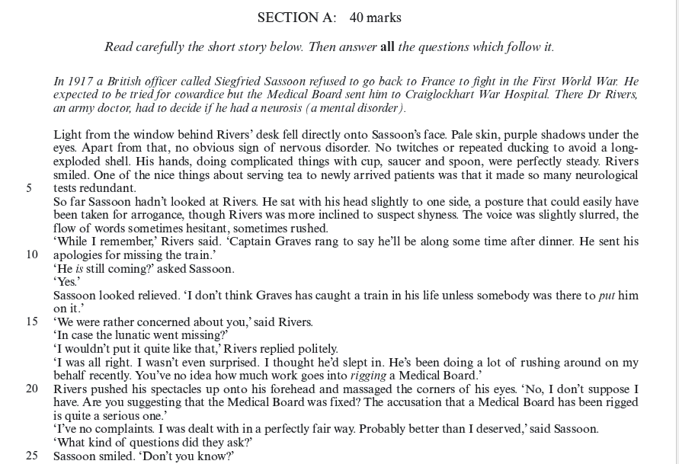

Look at lines 1-8.
A1. List five features we learn about Sassoon. [5]
Look at lines 6-23.
A2. How does the writer present the relationship between Rivers and Sassoon? [5]
Look at lines 24-50.
A3. How does the writer show the horrors of Sassoon’s experiences as a soldier? [10]
You should refer to:
- what happens;
- the choice of words and phrases.
Look at lines 51-89.
A4. What impressions do you get of Sassoon in these lines? [10]
Now consider the passage as a whole.
A5. Evaluate how the writer presents Rivers in the passage. [10]
You should write about:
- your own thoughts and feelings about how Rivers is presented in the passage as a whole
- how the writer has created these thoughts and feelings.

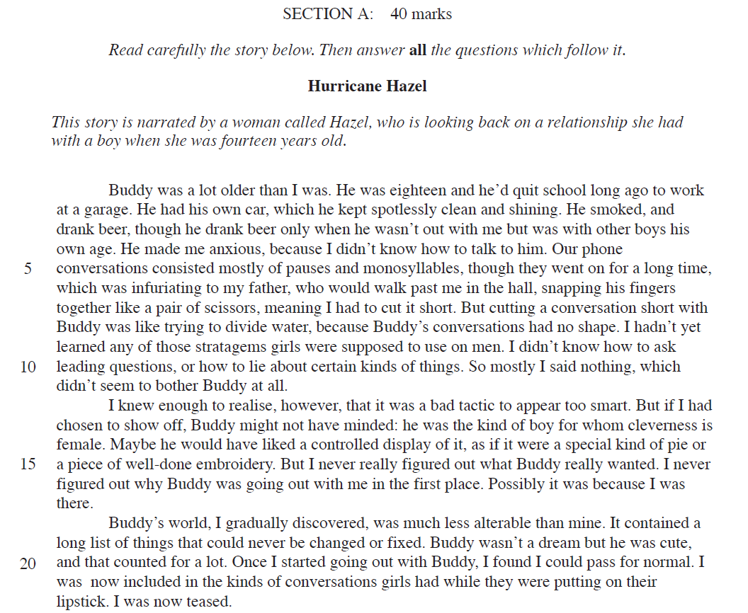
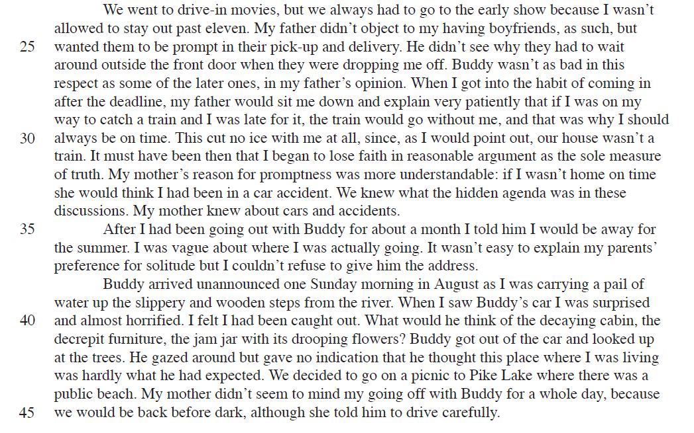
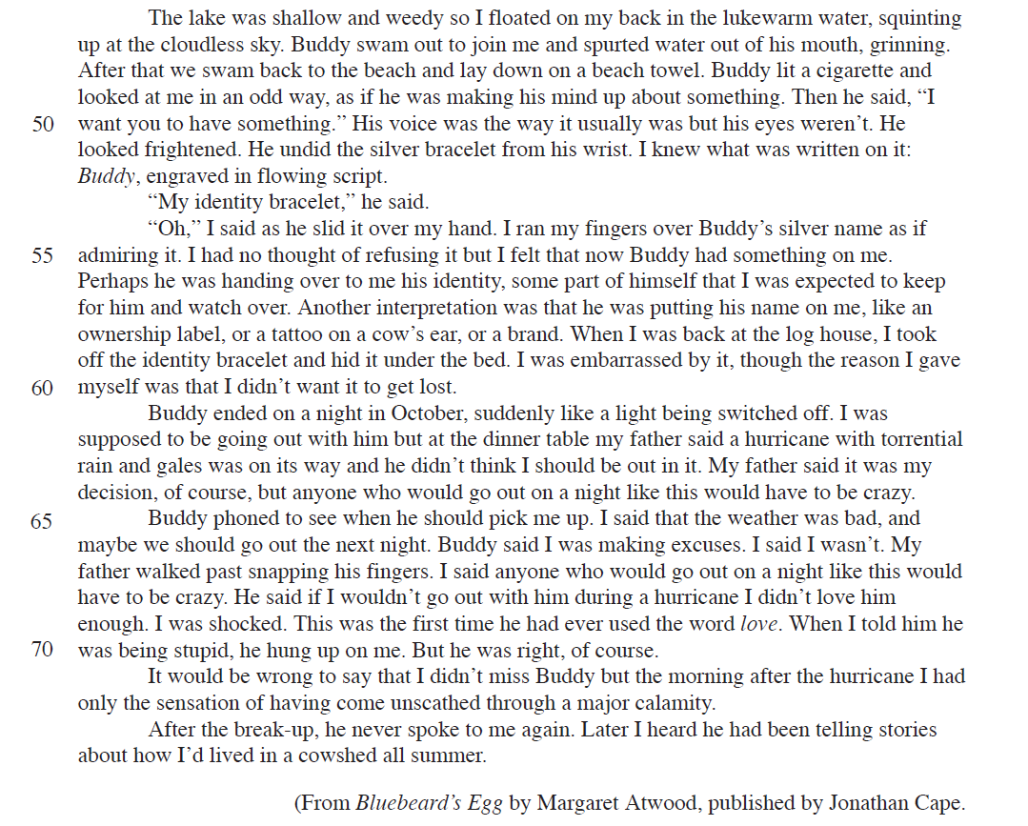
Read lines 1-11
A1. List five things you learn about Buddy in these lines. (5)

Read lines 12-22
A2. How does the writer show Buddy’s characteristics and personality in these lines? (5)
You must refer to the language used in the text to support your answer, using relevant subject terminology.

Read lines 23-60
A3 How does the writer that the relationship is not going to last? (10)
You should write about:
- what Maria does to attract his attention
- the writer’s use of language to show her interest in Justo
- the effects on the reader
You must refer to the text to support your answer, using relevant subject terminology.

Read lines 61 to the end.
A4 What impressions do you get of Buddy in these lines? (10)
You must refer to the text to support your answer, using relevant subject terminology.

Now consider the passage as a whole
A5. Evaluate the way Hazel is presented in this passage. (10)
You should write about:
- your own thoughts and feelings about how Hazel is presented in the passage as a whole
- how the writer has created these thoughts and feelings
You must refer to the text to support your answer.

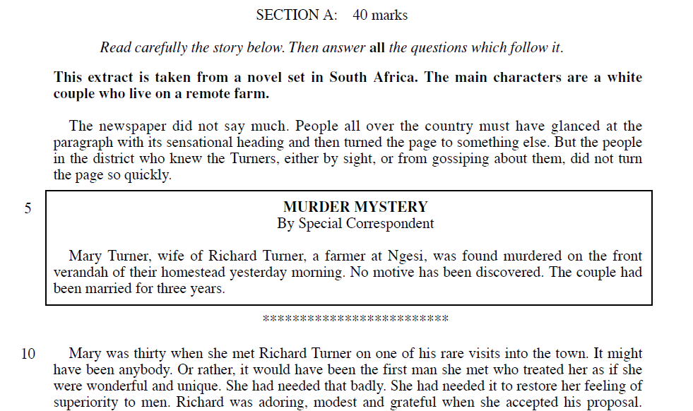

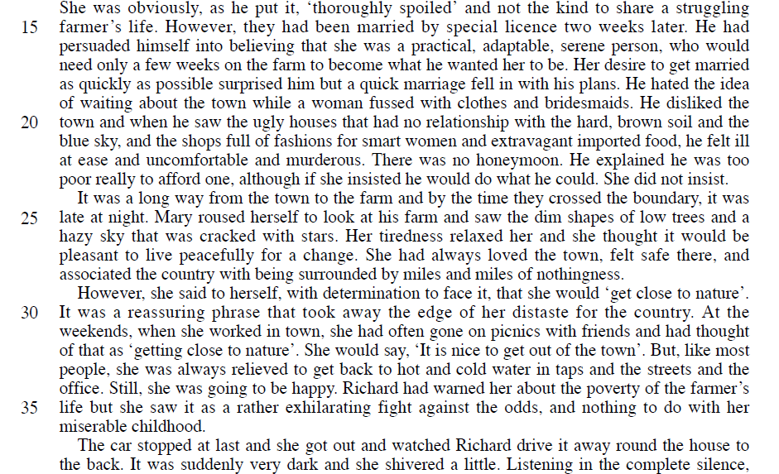
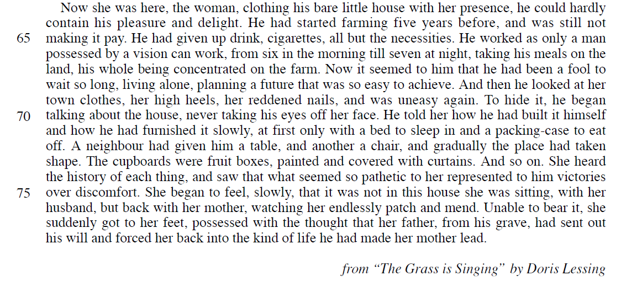

Read lines 1-14
A1. List five things you learn about Mary and Richard Turner in these lines. (5)

Read lines 15-28
A2 How does the writer show you the relationship between Mary and Richard in these lines? (5)
You must refer to the language used in the text to support your answer, using relevant subject terminology.

Read lines 29-54
A3 How does the writer show Mary’s thoughts and feelings in these lines? (10)
You should write about:
- the writer’s use of language to show her Mary’s thoughts and feelings
- the effects on the reader
You must refer to the text to support your answer, using relevant subject terminology.

Read lines 55 to the end.
A4 What impressions do you get of Richard in these lines? (10)
You must refer to the text to support your answer, using relevant subject terminology.

Now consider the passage as a whole
A5. Evaluate the way the relationship is presented in this passage. (10)
You should write about:
- your own thoughts and feelings about how the relationship is presented in the passage as a whole
- how the writer has created these thoughts and feelings
You must refer to the text to support your answer.

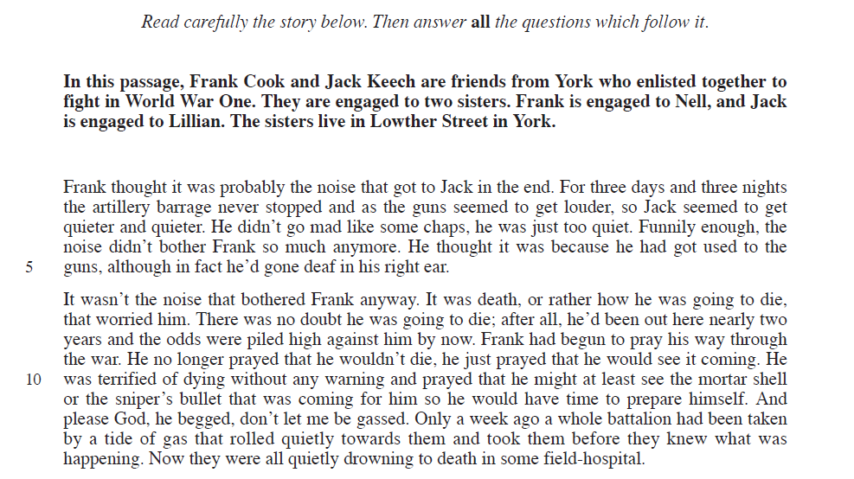
SECTION A: 40 Marks

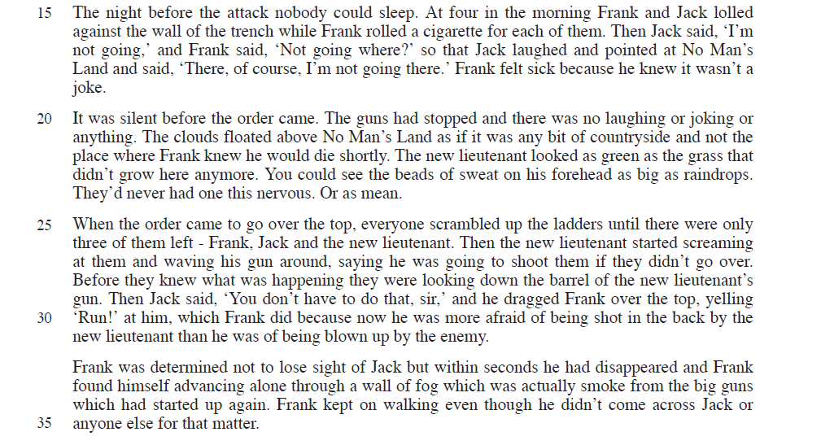

Read lines 1-11
A1. List five things you learn about Frank in these lines. (5)

Read lines 12-24
A2 How does the writer show you feelings of the men in these lines? (5)
You must refer to the language used in the text to support your answer, using relevant subject terminology.

Read lines 25-59
A3 How does the writer convey the horror of Frank’s experiences in these lines? (10)
You should write about:
- the writer’s use of language to show the horror of war
- the effects on the reader
You must refer to the text to support your answer, using relevant subject terminology.

Read lines 60 to the end.
A4 What impressions do you get of Lillian in these lines? (10)
You must refer to the text to support your answer, using relevant subject terminology.

Now consider the passage as a whole
A5. Evaluate the way the war is presented in this passage. (10)
You should write about:
- your own thoughts and feelings about how the war is presented in the passage as a whole
- how the writer has created these thoughts and feelings
You must refer to the text to support your answer.

SECTION B: WRITING

Spend 45 MINUTES hour on this section. This will test AO5 and AO6, which are both about the quality and accuracy of your writing.

What will the paper look like?

Unlike Section A, where there is a specific strategy for answering each type of question, in Section B there is much more room for creativity and individual expression. However, there are still a number of tips for success the examiner has suggested you should follow!

Examiner’s Tips for Narrative Writing

- You can write in the 1st or the 3rd person
- Do not write one in advance, memorise it and then try to make it fit into the title given – this is obvious to examiners and you will be putting yourself at a disadvantage.
- Use setting to develop character and plot.
- Do not include aliens, blood, axe murderers, setting in a forest – examiners are very bored of these ideas!
- If you can, keep the story ‘small’. As we’ve said, no one cares about aliens or axe murderers. Keep your characters and your situations ‘real’ and relatable.
- If you need to use time shifts, then sentence starters for each paragraph might help, such as: “Later that night…” “The next morning…” “Little did they know…” “If they could see me now…” “Overnight they thought about…” “As the night/day/week passed…”
- If you’re using dialogue, then learn to punctuate it properly! There is advice on this later in this guide.

Punctuating Dialogue Properly

- Use the same capitalization within a quotation as you would if it were a normal sentence.

- A full direct quotation always begins with a capital letter.
Ex. He said, “Only if we do all our homework first.”

- When a quoted sentence is divided into two parts, the second part begins with a lower case letter.
Ex. “You may go,” said our father, “if you are done with your homework.”

- When speech stands alone without dialogue tags [he said, AND John yelled are dialogue tags], it is enclosed in quote marks and the punctuation lies inside the quotes.
“Mark, this is the file I want copied.”
“Mark, is this the file you want copied?”
“Mark, what a huge file!”

TRY IT YOURSELF – punctuate the following as tag-free dialogue (as above).

- I see you have mastered basic dialogue punctuation
- What else would you expect from a literary genius
- What an enormous ego

- When a tag goes on the front, it is followed by a comma. The rest remains the same.
Jack said, “Mark, this is the file I want copied.”
Jack said, “Mark, is this the file you want copied?”

TRY IT YOURSELF – punctuate the following with dialogue tags (as above).

- Trish said hey I’ve got a good idea
- Bill replied spill the beans
- Marty said will it take all night

- When a tag is added after the speech, the full stop (period) inside the final quote mark becomes a comma, and the full stop/period moves to the new end of the sentence.
“Mark, this is the file I want copied,” Jack said.
“I am hotly opposed to this, Henley,” Sarah said.
“I have absolutely no objection,” Lord Moncreiff replied.

TRY IT YOURSELF – punctuate the following with dialogue tags (as above).

  - Julie I am deeply indebted to you Bill said
  - Don’t tell me Tom’s come back home Arthur said
  - There is nothing to the rumour then George said Nancy

- However, when the speech ends in a question mark or exclamation mark, and a tag is added at the end, question marks and exclamations remain unchanged and there is no bridge at all between the speech and the tag. DON’T add a comma.

“Mark, what a huge file!” Jack said.
“Mark, is this the file you want copied?” Jack said.
“How do you explain that, George?” she asked.
TRY IT YOURSELF – punctuate the following with dialogue tags (as above).
- Who wants to go to the movies Marcia asked
- Holy cow Mike yelled
- Is that the best you can do Charles Lulubelle said

- When the tag is inserted somewhere inside a complete sentence, commas are used before and after, and new quote marks are added to show where speech stops and starts again, on either side of the authorial intrusion.

Joan said, “Mary, did you ever expect a murder to happen right next door?”
“Mary,” Joan said, “did you ever expect a murder to happen right next door?”
“Mary, did you ever expect,” Joan said, “a murder to happen right next door?”
“Mary, did you ever expect a murder to happen,” Joan said, “right next door?”
You will notice that, when the interrupted sentence continues, it does not take a capital letter. This is true, even in the first example, when only “Mary” is isolated, leaving a complete sentence on the other side. The key to this dialogue punctuation – the question you must ask yourself – is “Was it one whole sentence before I messed with it?” If so, then I must show the interruptions with commas only.
TRY IT YOURSELF – punctuate the following with dialogue tags (as above).
Mary replied, “Joan, I’ll have you know, in this neighbourhood murders are a dime a dozen.”
Joan Mary replied I’ll have you know, in this neighbourhood murders are a dime a dozen
Joan, I’ll have you know Mary replied in this neighbourhood murders are a dime a dozen
Joan, I’ll have you know, in this neighbourhood Mary replied murders are a dime a dozen

- When two complete sentences are connected by a tag, however, no sentence is actually interrupted, so the first sentence is treated as in (3) above, and the second sentence starts with a capital and stands alone.
Here are the two distinct sentences:
Mary, I didn’t know this town was so evil.
You’ve been chatting every morning to a murderer.
Here’s how we connect them:
“Mary, I didn’t know this town was so evil,” Joan said. “You’ve been chatting every morning to a murderer.”

So, a first sentence that ends with an exclamation mark or question mark will remain unchanged:

“Mary, what an evil town!” Joan said. “Fancy a murder happening right next door.”

“Mary, did you ever expect that?” Joan said. “Fancy a murder happening right next door.”

TRY IT YOURSELF – punctuate the following with dialogue tags (as above).
I have never liked this town Mary said It makes me feel depressed
Is that the local beauty queen Jill said I thought she’d be prettier than that
What a load of nonsense Mike replied there’s no such thing as ghosts

- It is also a generally recognised convention that each time the dialogue moves from one speaker to another, the writer takes a new paragraph. This results in:

“Have you found the course interesting and fruitful, my dear?” he asked. His tone indicated that he was a little fearful she might say no. He peered over his half-glasses.

“Oh, Dr Edwards, how could it be otherwise, when we have the benefit of a great mind like yours applying itself to the greatest, most profound, issues of the human condition? Not to mention that you’re totally gorgeous.” Delilah batted her eyes at him, sending a shower of mascara down his tie.

“Gorgeous is good. Keep talking,” Edwards mumbled, as he stuffed one of the ridiculously small sandwiches into his mouth.

When there are no tags, it results in exchanges such as this:

“That’s stupid!”
“S’not stupid. If your father was poor, instead of rich and famous, you’d think the same. I’m going to do it, anyway.”
“Bet you don’t.”
“You see if I don’t!”
“You’re wacko!”
“Maybe I am, but I got guts. That’s something you never heard of.”

This works well, if it doesn’t go on too long or so long that the reader becomes confused about who is speaking.

Mark Scheme

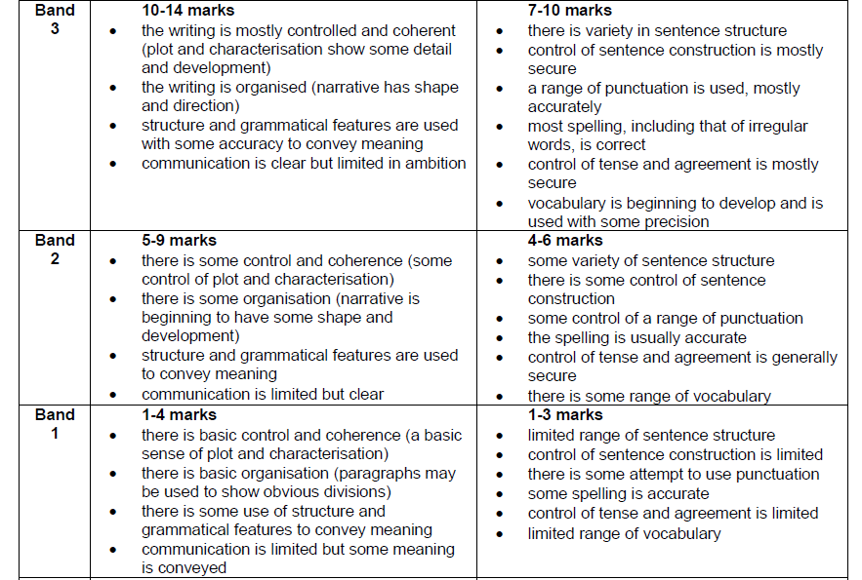

Student’s Examples

