English Literature: Component 2, Section A

**An Inspector Calls**

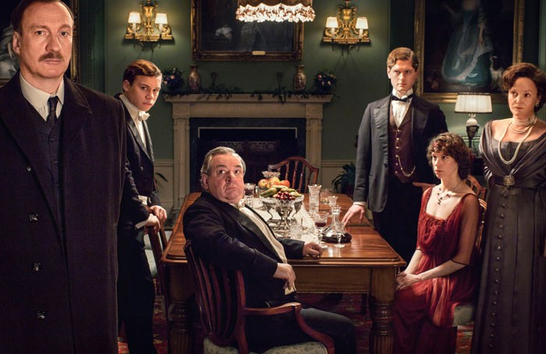

DATE OF EXAM:

One question. 45 minutes.

Name:

Class:

Teacher:

**How do I revise for An Inspector Calls?**

1. **Read the play!** If you already have, that’s great; you can always read it again. *Try to* ***actively*** *read the book.*

**How do I do that?** *Use post-it notes to records ideas; look out for a particular theme or character.* *Ask questions of what’s happening.*

1. **Get organised!** You have lots of stuff on this book already. Find it. Sort it. And use it.
2. **Know what is going on.** Produce mind maps/summaries of each Act and character. Know what happens and when it happens and also why it’s important.
3. **Know who is who.** Eva/Daisy, Sheila, Eric, Gerald, Mrs Birling and Mr Birling. Even Edna. What do they all represent? Be able to write 5 bullet points for each character (personality/appearance/role in the play) and find 5 (minimum) key quotes for them-put it on a big sheet of paper and stick it on your bedroom wall - AND LOOK AT IT!
4. **Be clear on the themes.** There are lots of themes explored in this play. Know what they are, why they’re important and which characters have something to do with them.
   * **Make a note of what they are-look for some examples**
   * **Who has something do with them**
   * **Some key quotes**
   * **Put it all on some sort of mind map. (Again, look at it from time to time once it’s done!)**
5. **Learn lots of short quotes.** Don’t forget you can’t take your book into the exam. Get some cue cards-write 5 key quotes for each theme and each character on them and learn them! On the bus, in the car, just before bed...you get the idea. Stick them in your bag and take them with you, everywhere you go!
6. **Plan some essays.** Time yourself, spend ten/fifteen minutes writing down and then organising your ideas for different questions.
7. **Do some practice papers.** You’ll find lots of past papers in this booklet. Use them!

**Assessment Criteria**

**Complete this box with key details relating to the exam:**

|  |  |
| --- | --- |
| **What I have to do** | **AO1** |
|  |  |
| **AO2** |
|  |
| **AO4** |
|  |

**An Inspector Calls Revision Questions**

**Task**: Use these questions to revise. How you do it is up to you and your revision and learning style:

**Mr Birling**

1. Name three reasons why Mr Birling is happy at the start of the play.
2. What is Mr Birling’s opinion on what the future holds?
3. Find three examples of how the Inspector unsettles Mr Birling.
4. Do you think Mr Birling just wants to suppress the young people that challenge his authority?
5. What do you think Mr Birling is most worried about when the Inspector leaves?

**Mrs Birling**

1. How good is Mrs Birling at being a wife and mother? Find examples.
2. Find three examples of her being a snob.
3. What does Mrs Birling learn from the Inspector’s visit?
4. What is she most concerned about throughout the play?

**Sheila**

1. What is Sheila like at the start of the play? Find quotes.
2. Why did she ask for Eva/Daisy to be fired from Milwards?
3. What reason does she give for not taking Gerald back?
4. Is she a strong female character? Explain your reasons.
5. In what way does she become like the Inspector?

**Eric**

15

. Find three examples of Eric behaving strangely at the beginning

of the play.

. How do Eric’s parents feel about him? (think: about his role in the

16

business? About the prostitutes? About the baby? etc)

17

. Do you think his upbringing is an excuse for his alcoholism and

the way he treated Eva/Daisy?

18

. Does the audience sympathise with Eric? If so/ not, why?

. How does Eric feel about his parents at the end of the play?

19

**Gerald**

20

. Why are Mr and Mrs B pleased Sheila is marrying Gerald, rather

than someone else?

. Find three ways that are Sheila and Gerald different from each

21

other.

22

. How do you feel about Gerald’s relationship with Daisy?

23

. Why do you think Gerald broke it off with Daisy?

**Eva/ Daisy**

. Describe what Eva/Daisy looked like, using the various

24

descriptions given of her by the other characters.

25

. Do you think Eva and Daisy where the same person? Why?

26

. How do each of the characters react to the fact that no girl

committed suicide that day?

**Inspector Goole**

27

. Find three examples of different ways in which the Inspector

intimidates the Birlings and Gerald.

28

. Why does he say things like ‘I don’t play golf’?

29

. Do you think the Inspector liked any of the Birlings or Gerald?

30

. Who is the Inspector?

**Notes on the Play**

**One of the best ways to revise is make your own notes as you read. Don’t JUST read. Use the following information below and turn it into your own mind maps, lists, flashcards, cue cards… whatever helps it go into your head!**

**So… what’s the play about?**

**The play is about, amongst many things, social responsibility**. Priestley uses the play to present his ideas on responsibility and society. He frequently uses the **character of the Inspector as a mouth-piece for his ideas**. For example the Inspector exclaims ‘We are members of one body. We are responsible for each other’**. Priestley is suggesting that we should all look after one another**, and that those who have power over others should use it for the common good, not just for their own benefit. It is fairly clear by the end of the play that these are Priestley’s views.

**Plot**

1. The Birling Family and Gerald Croft are having a dinner celebrating Sheila Birling’s engagement to Gerald Croft.
2. Just as Mr Birling is at his most confident; an inspector arrives to investigate a suicide.
3. Mr Birling reveals he sacked Eva Smith.
4. Sheila explains that she had Eva sacked from her next job at Milwards.
5. Gerald recognises the name Daisy Renton (Eva’s second name)
6. Gerald admits that he kept Daisy as his mistress.
7. Mrs Birling tells the group that she denied help to a pregnant girl when she went to Mrs Birling’s charity organisation
8. Eric enters, just as we realise he is the father of the child.
9. Eric explains his relationship with the girl and how he stole money to help her.
10. The Inspector leaves.
11. The family gradually realises the Inspector could have been a fraud.
12. The celebratory mood is almost restored – then a phone call announces that an Inspector is on his way to investigate a girl’s suicide.

**Dramatic Devices:**

Priestley uses a range of dramatic devices for different purposes. For example, **set, lighting, sound effects, props, characterisation, timing and dramatic irony.**

**Stage Directions**

At the beginning of Act 1 he uses **stage directions to set the scene and give us information about the Birling family** before we even see them. We can tell that the **Birling family are a comfortably off** middle to upper middle class family. We can also tell that they are **all feeling relaxed** and **confident** at the beginning of the play.

* set - *large suburban house*
* furniture - *‘solid …but not cosy and homelike’*
* props – suggests wealth *‘champagne glasses’, ‘decanter of port’*
* costume *‘evening dress of the period’* white tie and tails – a formal occasion
* lighting – *‘pink and intimate’*
* characters and how they are described by Priestley

At the start of the play the Birlings are seated and relaxed. By the end all standing and shouting/crying.

**Staging**- All the action takes place in one room- it is claustrophobic and intense- the pressure builds within the closed room. Birlings are shown to live in a closed, protected world and the Inspector is not welcomed from the outside.

Stephen Daldry’s 1992 production showed the house on stilts. Height showed the Birling’s separation from the rest of the town, but the stilts seemed unsteady- showing the Birling’s could easily fall from their status.

**Dramatic Irony.** (when an audience knows more about the characters/action than the characters on stage). Priestley uses **dramatic irony to show how ridiculous and wrong Birling’s opinions are.** E.g.:

* **Birling says war won’t happen** ‘I say there isn’t a chance of war’ but audience knows there were **two World Wars about to happen**
* Birling says that the **Titanic won’t sink** – ‘unsinkable’ – we know **it did, later that year.**
* Birling thinks **there’ll be no tension between employers and employees** ‘you’ll be living in a world that will have forgotten all these Capital versus Labour agitations’ but there were strikes in1907-1912 because of poor conditions and the **General Strike of 1926**
* The dramatic irony makes the audience think **Birling is foolish and lacking in knowledge about the future. It also makes his political opinions seem wrong. Priestley is also showing an audience his concern that such idiotic people have some degree of power in this society. Could you relate this to his Priestley’s experiences?**

**The entrance of the inspector**

* **Sound Effect**-There’s **a *‘sharp ring of a front door bell’***and Edna interrupts Birling in the middle of his speeches. The *‘sharp’* ring would startle the audience – and suggests that the Inspector may be a ‘sharp’ (as in intelligent and possibly aggressive) person. The ring also interrupts Birling suggesting that the Inspector will have power and control over Birling.
* There is a **change of lighting from *pink and intimate’* to *‘brighter and harder****’* when the inspector arrives. This suggests again that the Inspector is a ‘hard’ character who will wreck the cosy world the Birlings live in.
* His name ‘Inspector Goole’ also suggests something unpleasant/interesting about the inspector – e.g. ‘ghoul’ means ghost

**The inspector develops the dramatic tension**

The inspector *‘creates at once an impression of massiveness, solidity and purposefulness’.* He also speaks *‘carefully, weightily’* and *‘has a disconcerting habit of looking hard at the person he addresses before actually speaking’.* This interests an audience – **we want to know why he is there and how people will react** to his questioning.

The Inspector ‘inspects’ or interrogates each person in turn. He shows a photo of Eva Smith to each character in turn that only they see. The **audience is intrigued** and wants to know what this is.

* Interrogation of Birling. Birling feels uncomfortable and tries to threaten Goole with his friendship with Colonel Roberts. Audience think Birling is selfish and arrogant.
* Beginnings of **conflict between younger generation** (Sheila) and older generation (Birling). Sheila responds much more instinctively and emotionally to the report of Eva Smith’s death. This creates tension and the audience feel some sympathy for Sheila.
* Inspector leaves the room, having introduced Eva Smith’s change of name to Daisy Renton. **Audience want to know why this has occurred.**
* Look at the final exchange between Sheila and Gerald. In a sense, Sheila begins the inspector’s task. The fact that the audience knows that Gerald is involved (the third out of five characters) **suggests to the audience that the momentum will continue and that all the characters will be involved.**
* The inspector returns at the end of the scene and asks his question *‘Well?’* This is a **cliff-hanger – audience want to watch on to see how Gerald and Sheila react.**
* **Act 2 also ends with CLIFF HANGER. The front door slams, announcing Eric’s return, but the audience have to wait until Act 2 for his confession.**
* **(The front door bangs** every time someone enters or leaves the house. The characters and audience can hear this, and wonder who enters the house- **effective sound effect in creating tension.)**

**Timing**

* **Timing** of entrances and exits is crucial. For example, the Inspector arrives immediately after Birling has told Gerald about his impending knighthood and about how "a man has to look after himself and his own."
* **Sheila runs off stage when she realises she is the reason Eva was sacked - creates intense atmosphere.**
* **Sheila and Gerald are left alone to discuss Daisy Renton- this draws information out for audience.**
* A **great deal of tension has been created for the audience by the end of Act 1** and they have the desire to know how all the characters were involved. By having a break at this point between Acts One and Two and creating **a dramatic pause** Priestley creates **tension for the rest of the play**. Act 1 ends with the Inspector asking, “Well?” This builds suspense for the start of act 2 which begins with the same question and we are desperate for the answer.
* Tension is further created by the way **information is gradually revealed**, one person at a time. The audience and characters are kept on their toes.

Priestley has already **suggested to the audience some of the themes** that he develops later in his play: e.g. the idea that **those in power are often undeserving of that power** **and** **foolish** (as shown in his presentation of Birling in particular) and that the **younger generation are more open to positive change** (as in his presentation of Sheila’s remorse). Most importantly he has suggested that the Inspector is going to be the character to question the arrogant self-confidence that the Birlings have, just as he as a playwright confronts his audience’s own prejudices about power in society.

**The Ending**

The **ending** leaves the audience on a cliff-hanger. In Act 3 the Birlings believed themselves to be off the hook when it is discovered that the Inspector wasn't real and that no girl had died in the infirmary. This releases some of the tension - but the final telephone call, announcing that a real inspector is on his way to ask questions about the suicide of a young girl, suddenly restores the tension very dramatically. It is an unexpected final twist.

**Dramatic Structure/Genre**

Follows the rules of **Greek Drama**- the three unities of **place, action and time are kept to in a realistic manner**. i.e. The Drama all unfolds in one place- Birling’s Dining room. Action all takes place in one evening, time passes in the same way as in real life. This makes the play realistic.

The **Inspector acts like a Greek chorus (Narrator).** He sums up what has happened, and explains to both actors and the audience the lessons we must learn.

Equally might be seen as a simple **crime/ mystery play**- ‘Who dunnit?’

Furthermore, The play has **myth-like quality in that it carries a moral message** that we should take better care of our fellow human beings, so in some ways is like a **parable**.

**The Inspector himself adds dramatic tension**:

* He controls the **pace** and **tension** by dealing with one line of enquiry at a time. Slowly the story of Eva's life is unravelled, like in a 'whodunnit'.
* He is in command at the end of Act I and the start of Act 2, and the end of Act 2 and the start of Act 3. He is a brooding, inescapable presence, very much in control.
* He is very mysterious and seems to know what is going to happen before it does. Consider his name ‘Goole’. A ghoul is a ghost. Is he a supernatural being? The voice of Priestley or even God, come to morally judge them?

**Themes**

**Responsibility**

The Inspector wanted each member of the family to share the responsibility of Eva's death: he tells them, **"each of you helped to kill her."** However, his final speech is aimed not only at the characters on stage, but at the audience too:

**"One Eva Smith has gone - but there are millions and millions and millions of Eva Smiths and John Smiths still left with us, with their lives, their hopes and fears, their suffering and chance of happiness, all intertwined with our lives, and what we think and say and do."**

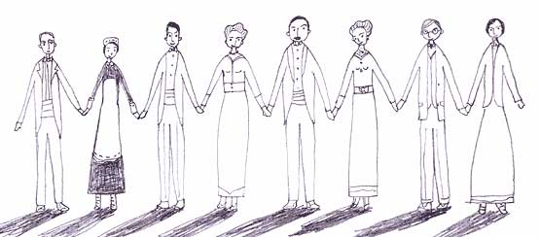

**Class**

Priestley is trying to show that the upper classes are unaware that the easy lives they lead rest upon hard work of the lower classes. They’re selfish/uncaring and immoral.

|  |  |  |
| --- | --- | --- |
| ATTITUDES TO THE LOWER CLASS: |  | ATTITUDES TO THE UPPER CLASS: |
| **To this character, Eva was...** |  | **At the start of the play, this character was:** |
| cheap labour | **Mr Birling** | keen to be knighted to cement his hard-fought rise to the upper class |
| someone who could be fired out of spite | **Sheila** | happy spending a lot of time in expensive shops |
| a mistress who could be discarded at will | **Gerald** | prepared to marry Sheila, despite her lower social position |
| easy sex at the end of a drunken night out | **Eric** | awkward about his 'public-school-and-Varsity' life |
| a presumptuous upstart | **Mrs Birling** | socially superior to her husband, and embarrassed at his gaffes |

**Age**

The older generation and the younger generation take the Inspector's message in different ways. While Sheila and Eric accept their part in Eva's death and feel huge guilt about it, their parents are unable to admit that they did anything wrong.

|  |  |
| --- | --- |
| **The Old** (Mr and Mrs Birling) | **The Young** (Sheila and Eric) |
| The old are set in their ways. They are utterly confident that they are right and they see the young as foolish. | The young are open to new ideas. This is first seen early in Act 1 when both Eric and Sheila express sympathy for the strikers - an idea which horrifies Birling, who can only think of production costs and ignores the human side of the issue. |
| The old will do anything to protect themselves: Mrs Birling lies to the Inspector when he first shows her the photograph; Mr Birling wants to cover up a potential scandal. | The young are honest and admit their faults. Eric refuses to try to cover his part up, saying, ***"the fact remains that I did what I did."*** |
| They have never been forced to examine their consciences before and find they cannot do it now - as the saying goes, 'you can't teach an old dog new tricks.' | Sheila and Eric see the human side of Eva's story and are very troubled by their part in it. They *do* examine their consciences. |
| Mr and Mrs Birling have much to fear from the visit of the 'real' inspector because they know they will lose everything. | Sheila and Eric have nothing to fear from the visit of the 'real' inspector because they have already admitted what they have done wrong, and will change |

**Gerald Croft** is caught in the middle, being neither very young nor old. In the end he sides with the older generation, perhaps because his aristocratic roots influence him to want to keep the status quo and protect his own interests.

Ultimately, we can be optimistic that the young - those who will shape future society - are able to take on board the Inspector's message.

**Gender**

An Inspector Calls was written after World War Two. As many British men went away to fight during the war, their positions in work had to be filled by women. This helped change existing perceptions. Men had to acknowledge the fact that women were just as capable as them. As a result of this, many women enjoyed a newfound freedom that working and earning money allowed them.

Not all men saw this change in attitude as a good thing and stayed stuck in the past. Priestley explores the impact of these new gender roles through the independence of Eva Smith and the sexist attitudes of Mr Birling.

In *An Inspector Calls* Priestley explores the theme of gender through:

* how Mr Birling and Gerald Croft view women
* how Mrs Birling treats Eva Smith
* how Eva Smith is portrayed as independent and outspoken before her death

|  |  |  |  |
| --- | --- | --- | --- |
| How Mr Birling refers to women | When Mr Birling is telling Eric and Gerald about women's attitudes towards the clothes they wear. | *"...not only something to make 'em look prettier - but - well, a sort of sign or token of their self-respect."* | Mr Birling shows that he has a patronising view of women, making the suggestion that clothes are a sign of self-respect for them. He has a stereotypical view of women here and does not see them as individuals but suggests that all women think in the same way. |
| How Gerald refers to women | Gerald makes sexist and superficial comments about the women in the bar he visits. | *"I hate those hard-eyed dough-faced women."* | Gerald shows that he can be very superficial in his view of women. If they don’t meet his standard of how they 'should' look, he dislikes them. |
| How Mrs Birling treats Eva Smith | When Mrs Birling suggests that Eva is incapable of having feelings. | *"She was claiming elaborate fine feelings and scruples that were simply absurd in a girl in her position."* | Priestley shows that even women like Mrs Birling can be just as cruel and old fashioned as the men are. She does not try to empathise with a member of her own gender. This also highlights her negative attitude towards the working class |

**SOME Character Quotes  
Make notes and learn them!**

**Inspector**

***Mystical and ghostly figure who calls to reveal to the Birlings how dangerous, selfish and immoral their lifestyles are.***

‘It’s better to ask for the earth than to take it.’ (14) The Insp’s lesson to Mr B is that at least Eva Smith only asked for a rise. Mr B just takes all of his money without asking anyone.

‘There are a lot of young women… if there weren’t the factories and warehouses wouldn’t know where to look for cheap labour. Ask your father.’ (19) The Insp shows he knows how business works and how the workers are exploited by Mr B.

Gerald points out that they are respectable citizens, not criminals. Insp says ‘Sometimes, there isn’t as much difference as you think … I wouldn’t know where to draw the line.’ (22) Insp suggests that even though no legal crime has been committed, they are guilty of a moral crime.

‘You were annoyed with yourself and passed the annoyance onto her.’ (25) The Insp knows why Sheila did what she did to Eva Smith.

‘She wanted to keep this youngster out of any more trouble – isn’t that so?’ (47) Eva Smith wouldn’t accept any more money from Eric because she thought he’d get into trouble for it. Eva is morally superior to her superiors – irony.

‘You’re offering the money at the wrong time, Mr Birling.’ (56) The Insp offers moral, not legal lessons. Mr Birling appears not to know the difference.

‘One Eva Smith has gone… but there are millions… of Eva Smiths… all intertwined with our lives… if men will not learn that lesson, then they will be taught it in fire and blood and anguish.’ (56) The message Priestley wanted to put across when he wrote the play?

**Birling**

***Bullying, mean head of the family who sees his employees as expensive machinery rather than human beings.***

‘look forward to a time when Croft’s and Birling’s are no longer competing but working together – for lower costs and higher prices.’ (4) Mr B may only want Gerald to marry his daughter for business purposes.

‘The Germans don’t want war… the Titanic, she sails next week… and unsinkable, absolutely unsinkable.’ (7) Mr B is wrong about the war and the Titanic. This is how the writer tells us he is wrong in the way he treats people too – dramatic irony to 1945 and modern audience. This links to pages 9/10 and his views, which the audience will also see as wrong. ***Good evidence to show you understand ‘structure’.***

‘The way some of these cranks talk now, you’d think everybody has to look after everybody else.’ (10) Mr B can only ever think of looking after himself.

‘But it doesn’t convey anything to me.’ (12) Mr B doesn’t even remember sacking Eva Smith until he is reminded about it.

‘Public men, Mr Birling, have responsibilities as well as privileges.’ Insp suggesting that Mr B has a ‘duty of care’ to his employees – something we take for granted in 2012. (41)

**Mrs Birling**

***A snobbish woman who judges everyone by their financial situation, not by their character.***

‘Girls of that class…’ (30) Mrs B looks at everyone as members of various classes, not as human beings.

‘Alderman Meggarty… we are learning something tonight.’ (35) Mrs B realizes that people she thought were civilised are corrupt and immoral. Suggests the wealthy are remote from reality? Link to today?

‘She seemed to me to be not a good case – and so I used my influence to have it refused.’ (44) Mrs B admits turning the girl away but refuses to accept that this was wrong. Very matter of fact language.

‘Some drunken young idler, then that’s all the more reason why he shouldn’t escape.’ (48) Mrs B doesn’t yet know that the drunken idler is her own son. As a hypocrite, she doesn’t say the same when she finds out!

**Sheila**

***A basically warm hearted girl who admits that she suffers from sudden jealousies. She eventually realises that they did wrong to the girl, unlike her parents.***

‘She was a very pretty girl too… and that didn’t make it any better.’ ‘I couldn’t be sorry for her.’ (24) Sheila admits to being jealous of Eva Smith.

‘…talked about building up a wall that’s sure to be knocked flat.’ (32) As one of the more intelligent characters, Sheila suspects that it is useless to try and fool the inspector.

‘I don’t care about that, the point is that you don’t seem to have learnt anything.’ (58) Sheila reveals her generous nature and that she knows that whether the girl died or not, the sins they committed are still with them / have taken place.

‘I suppose we’re all nice people now.’ (63) As above. Ironic tone.

**Eric**

***A basically pleasant young man but he admits he drinks too much and doesn’t work hard enough. He eventually realizes that they treated the girl badly.***

‘She wouldn’t take any more and she didn’t want to see me again.’ (54) Eric explains how Eva/Daisy behaved more decently, even in poverty, than any of the Birlings did. Wouldn’t accept stolen money.

‘and the child she’d had too – my child – your own grandchild – you killed them both – damn you-‘ (55) Eric reveals the Insp’s ability to turn them against themselves. Hyphens used to show his distress – harsh language used. Don’t forget to look at the stage directions as well!

‘The money’s not the important thing. It’s what happened to the girl and what we all did to her that matters.’ (65) Eric proves that he is good at heart and understands that they were morally very bad to the girl.

**Gerald**

***Another gentle character who might have helped Eva in generosity but allowed his superiority over her to lead to sex. Perhaps he should have considered what would happen to the girl when his help stopped, as it was always going to.***

‘And I’ve told you – I was awfully busy at the works all that time.’ (3) Gerald proves that he is capable of being so dishonest to someone he should respect, i.e. Sheila.

‘I didn’t install her there so I could make love to her… I was sorry for her.’ (37) Gerald may have tried to help her but he never considered what would happen when he took the help away.

‘She told me she’d been happier than she’d ever been before.’ (39) As above. Gerald’s sense of generosity is not only providing him with sex without responsibilities, it is also misplaced.

**Themes – Make your own notes!**

**Social   
Responsibility**

**Gender**

**Age and the differences   
between generations**

**Class**

***Exam Practice Paper 1.***

*You are advised to spend about 45 minutes on this question.*

**You should use the extract below and your knowledge of the whole play to answer this question.**

Write about Eric and how he is presented at different points in the play. In your response you should:

* refer to the extract and the play as a whole;
* show your understanding of characters and events in the play. [40]

*5 of this question’s marks are allocated for accuracy in spelling, punctuation and the use of vocabulary and sentence structures.*

(*Eric goes for a whisky. His whole manner of handling the decanter and then the drink shows his familiarity with quick heavy drinking. The others watch him narrowly*.)

Inspector: When did you first meet this girl?

Eric: One night last November.

Inspector: Where did you meet her?

Eric: In the palace bar. I'd been there an hour or so with two or three chaps. I was a bit squiffy.

Inspector: What happened then?

Eric: I began talking to her, and stood her a few drinks. I was rather far gone by the time we had to go.

Inspector: Was she drunk too?

Eric: She told me afterwards that she was a bit, chiefly because she'd not had much to eat that day.

Inspector: Why had she gone there-?

Eric: She wasn't the usual sort. But – well, I suppose she didn't know what to do. There was some woman who wanted to help her go there. I never quite understood about that.

Inspector: You went with her to her lodgings that night?

Eric: Yes, I insisted – it seems. I'm not very clear about it, but afterwards she told me she didn't want me to go in but that – well, I was in that state when a chap easily turns nasty – and I threatened to make a row.

Inspector: so she let you in?

Eric: Yes. And that's when it happened. And I didn't even remember – that's the hellish thing. Oh – my God! - how stupid it all is!

Inspector: When did you meet her again?

Eric: About a fortnight afterwards.

Inspector: By appointment?

Eric: No. And I couldn't remember her name or where she lived. It was all very vague. But I happened to see her again in the palace bar.

Inspector: More drinks?

Eric: Yes, though that time I wasn't so bad.

Inspector: But you took her home again?

Eric: Yes. And this time we talked a bit. She told me something about herself and I talked too. Told her my name and what I did.

Inspector: And you made love again?

Eric: Yes. I wasn't in love with her or anything – but I liked her – she was pretty and a good sport.

***Exam Practice Paper 2.***

*You are advised to spend about 45 minutes on this question.*

**You should use the extract below and your knowledge of the whole play to answer this question.**

Write about Gerald and how he is presented at different points in the play. In your response you should:

* refer to the extract and the play as a whole;
* show your understanding of characters and events in the play. [40]

*5 of this question’s marks are allocated for accuracy in spelling, punctuation and the use of vocabulary and sentence structures.*

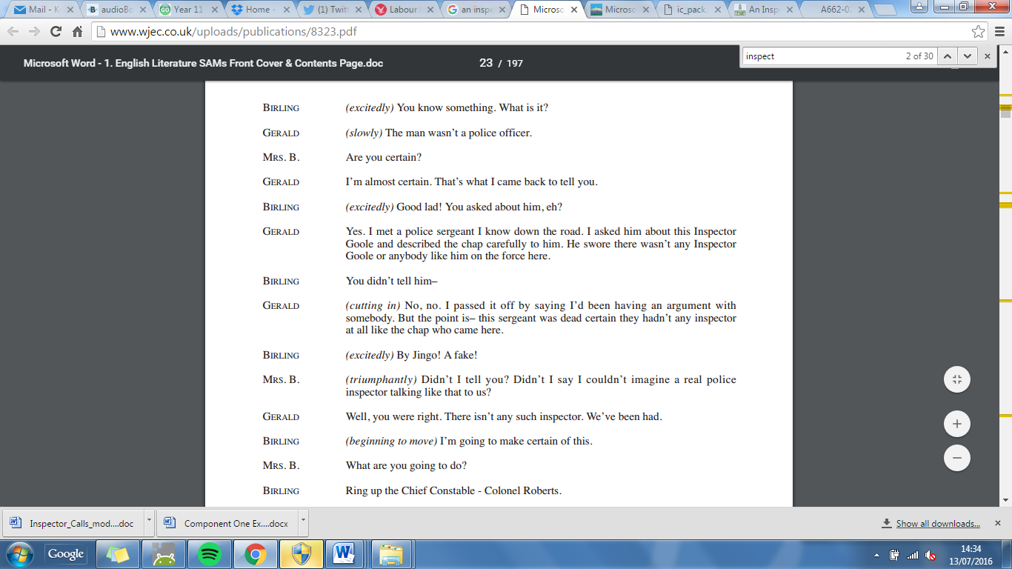

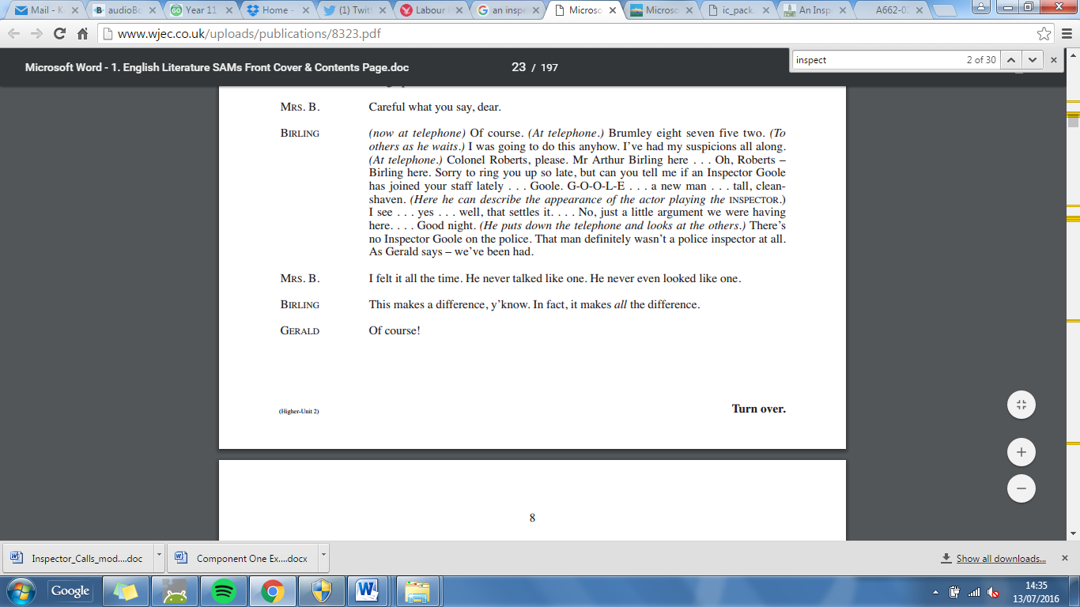

***Exam Practice 3.***

*You are advised to spend about 45 minutes on this question.*

**You should use the extract below and your knowledge of the whole play to answer this question.**

Write about Mr Birling and how he is presented in the play. In your response you should:

* refer to the extract and the play as a whole;
* show your understanding of characters and events in the play. [40]

*5 of this question’s marks are allocated for accuracy in spelling, punctuation and the use of vocabulary and sentence structures.*

Birling: (*rather heavily*) I just want to say this.(*noticing that Sheila is still admiring her ring*.) are you listening, Sheila? This concerns you too. And after all I don't often make speeches at you -

Sheila: I’m sorry, daddy. Actually I was listening. (S*he looks attentive, as they all do. He holds them for a moment before continuing*)

Birling: I’m delighted about this engagement and I hope it won't be too long before you're married. And I want to say this. There's a good deal of silly talk about these days – but – and I speak as a hard-headed business man, who has to take risks and know what he's about – I say, you can ignore all this silly pessimistic talk. When you marry, you'll be marrying at a very good time. Yes, a very good time – and soon it'll be an even better time. Last month, just because the miners came out on strike, there's a lot of wild talk about possible labour trouble in the near future. Don't worry. We've passed the worst of it. We employers at last are coming together to see that our interests – and the interests of capital – are properly protected. And we're in for a time of steadily increasing prosperity.

Gerald: I believe you're right, sir.

Eric: What about war?

Birling: Glad you mentioned it, Eric. I'm coming to that. Just because the Kaiser makes a speech or two, or a few German officers have too much to drink and begin taking nonsense, you'll hear some people say that war's inevitable. And to that I say – fiddlesticks! The Germans don't want war. Nobody wants war, except some half-civilized folks in the Balkans. And why? There's too much at stake these days. Everything to lose and nothing to gain by war.

Eric: Yes, I know – but still -

Birling: Just let me finish, Eric. You've a lot to learn yet. And I’m taking as a hard headed, practical man of business. And I say there isn't a chance of war. The world's developing so fast that it'll make war impossible. Look at the progress we're making. In a year or two we'll have aeroplanes that will be able to go anywhere. And look at the way the auto-mobile's making headway – bigger and faster all the time. And then ships. Why, a friend of mine went over this new liner last week – the titanic – she sails next week – forty-six thousand eight hundred tons – new york in five days – and every luxury – and unsinkable, absolutely unsinkable. That's what you've got to keep your eye on, facts like that, progress like that – and not a few german officers taking nonsense and a few scaremongers here making a fuss about nothing. Now you three young people, just listen to this – and remember what I’m telling you now. In twenty or thirty year's time – let's say, in 1940 – you may be giving a little party like this – your son or daughter might be getting engaged – and I tell you, by that time you'll be living in a world that'll have forgotten all these capital versus labour agitations and all these silly little war scares. There'll be peace and prosperity and rapid progress everywhere – except of course in russia, which will always be behindhand naturally.

Mrs Birling: Arthur!

Birling: Yes, my dear, I know – I’m talking too much. But you youngsters just remember what I Said. We can't let these Bernard Shaws and H.G.Wellses do all the talking. We hard-headed practical business men must say something sometime.

***Exam Practice 4.***

*You are advised to spend about 45 minutes on this question.*

**You should use the extract below and your knowledge of the whole play to answer this question.**

Write about Mrs Birling and how she is presented at different points in the play. In your response you should:

* refer to the extract and the play as a whole;
* show your understanding of characters and events in the play. [40]

*5 of this question’s marks are allocated for accuracy in spelling, punctuation and the use of vocabulary and sentence structures.*

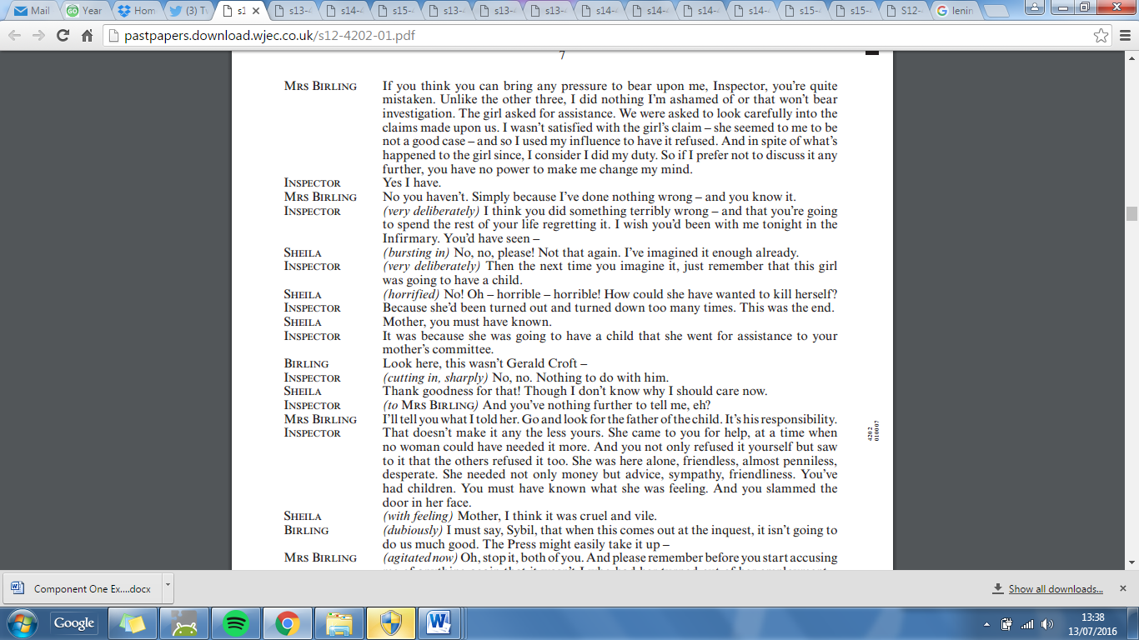

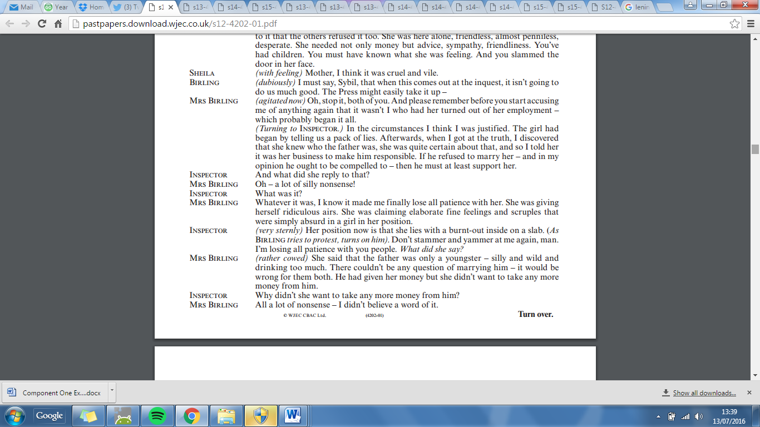

***Exam Practice 5.***

*You are advised to spend about 45 minutes on this question.*

**You should use the extract below and your knowledge of the whole play to answer this question.**

Write about the theme of responsibility and how it is presented in An Inspector Calls. In your response you should:

* refer to the extract and the play as a whole;
* show your understanding of characters and events in the play. [40]

*5 of this question’s marks are allocated for accuracy in spelling, punctuation and the use of vocabulary and sentence structures.*

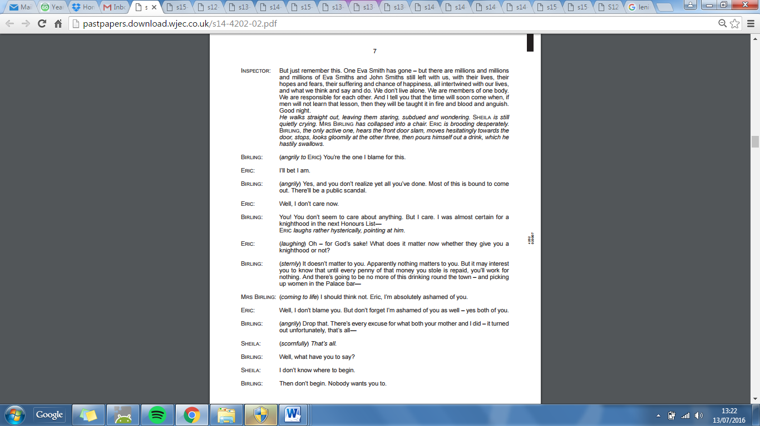

***Exam Practice 6.***

*You are advised to spend about 45 minutes on this question.*

**You should use the extract below and your knowledge of the whole play to answer this question.**

Write about Sheila and the way she changes in the play. In your response you should:

* refer to the extract and the play as a whole;
* show your understanding of characters and events in the play. [40]

*5 of this question’s marks are allocated for accuracy in spelling, punctuation and the use of vocabulary and sentence structures.*

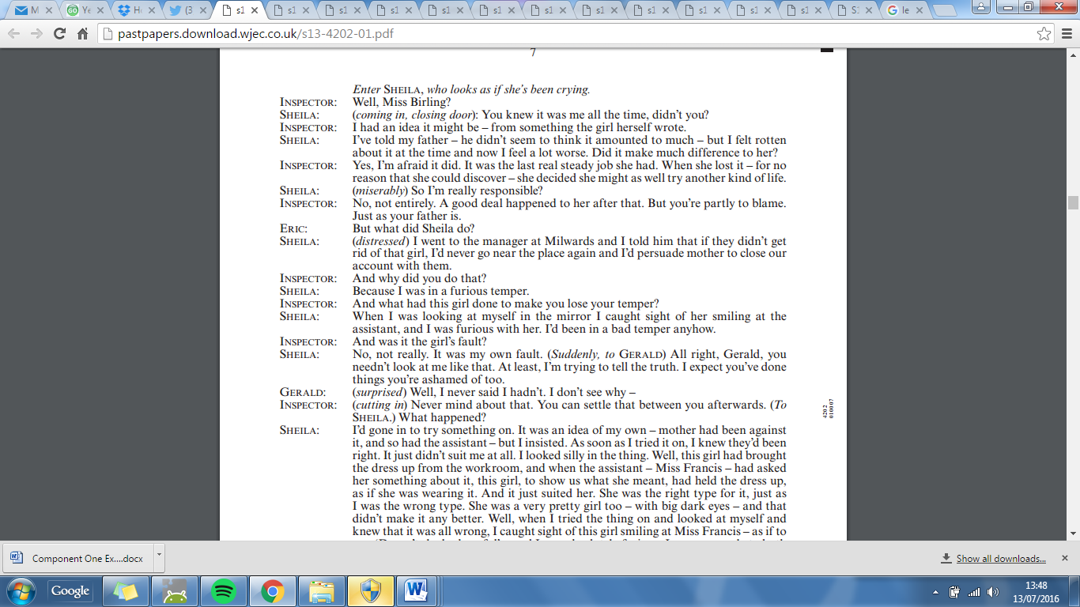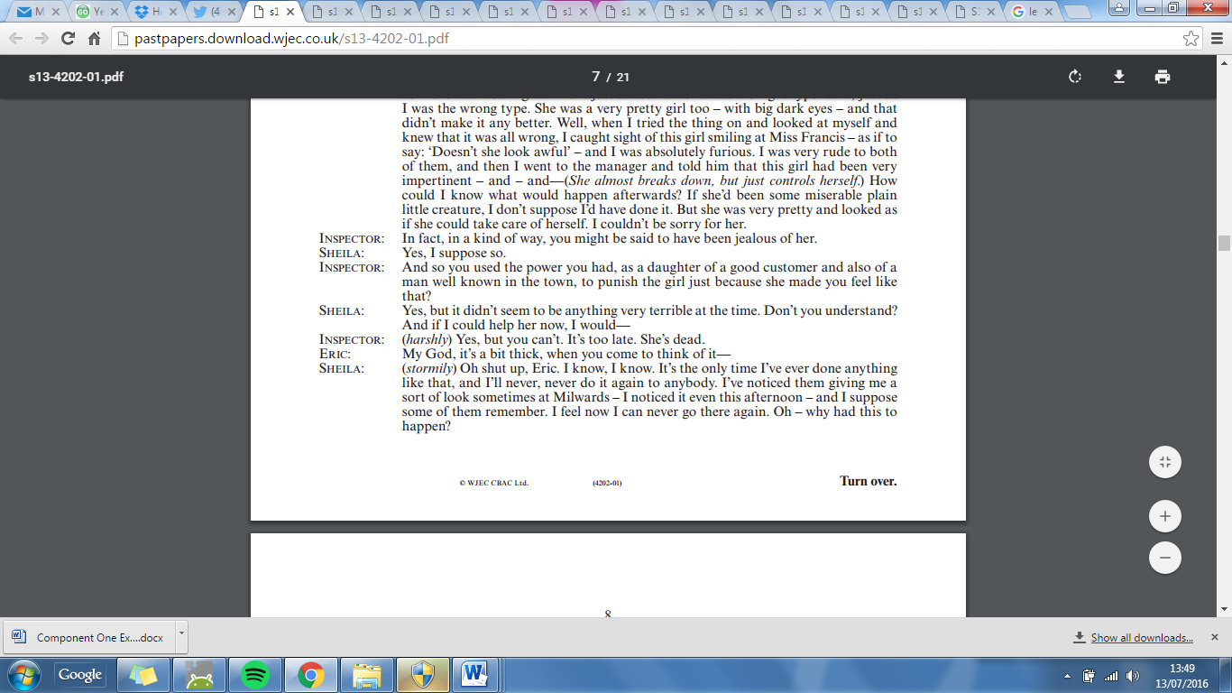

***Exam Practice 7.***

*You are advised to spend about 45 minutes on this question.*

**You should use the extract below and your knowledge of the whole play to answer this question.**

Write about how the difference in attitudes between the generations is presented in the play. In your response you should:

* refer to the extract and the play as a whole;
* show your understanding of characters and events in the play. [40]

*5 of this question’s marks are allocated for accuracy in spelling, punctuation and the use of vocabulary and sentence structures.*

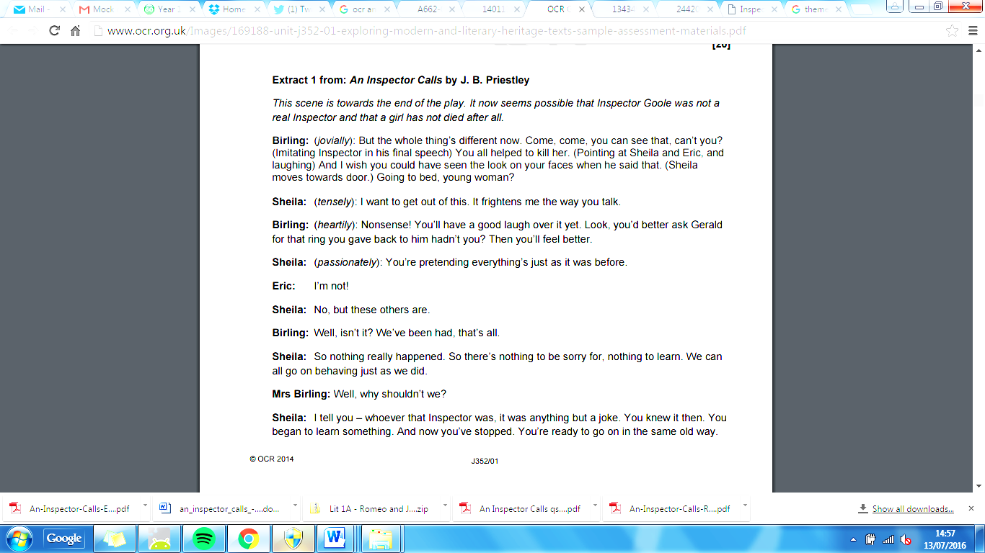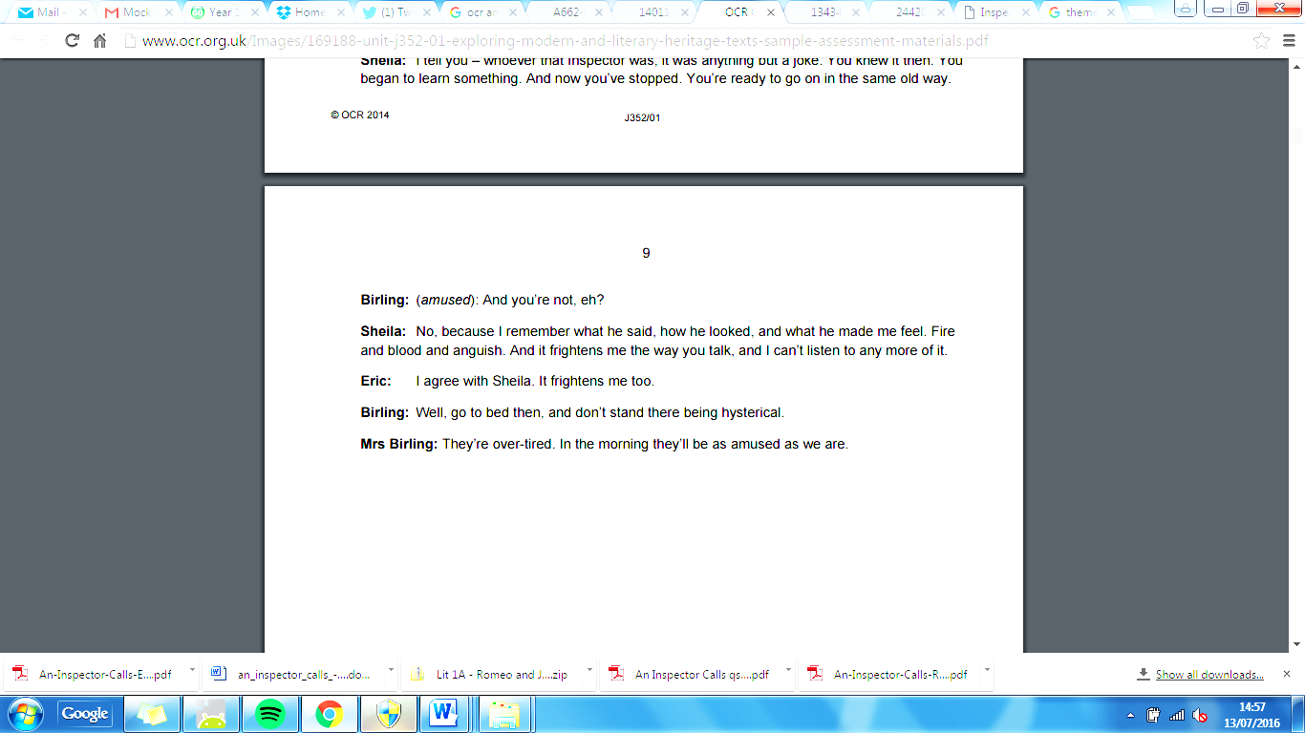

**Mark Scheme**

**AO1 and AO2 are equally weighted in this question.**

This assessment also includes 5 marks for accuracy in spelling, punctuation and the use of vocabulary and sentence structures (AO4). There is a separate assessment grid for AO4. **Total marks 35+5**

|  |  |  |
| --- | --- | --- |
| **Band** | **AO1** | **AO2** |
| **5**    **29-35 marks** | Candidates:  sustain focus on the task, including overview, convey ideas with consistent coherence and use an appropriate register; use a sensitive and evaluative approach to the task and analyse the extract and wider text critically; show a perceptive understanding of the extract and wider text, engaging fully, perhaps with some originality in their personal response; their responses include pertinent, direct references from across the extract and wider text, including quotations. | Candidates: analyse and appreciate writers’ use of language, form and structure; make assured reference to meanings and effects exploring and evaluating the way meaning and ideas are conveyed through language structure and form; use precise subject terminology in an appropriate context. |
| **4**    **22-28 marks** | Candidates: sustain focus on the task, convey ideas with considerable coherence and use an appropriate register; use a thoughtful approach to the task; show a secure understanding of key aspects of the extract and wider text, with considerable engagement; support and justify their responses by well-chosen direct reference to the extract and wider text, including quotations. | Candidates: discuss and increasingly analyse writers’ use of language, form and structure; make thoughtful reference to the meanings and effects of stylistic features used by the writer; use apt subject terminology. |
| **3**    **15-21 marks** | Candidates: focus on the task, convey ideas with general coherence and use a mostly appropriate register; use a straightforward approach to the task; show an understanding of key aspects of the extract and wider text, with engagement; support and justify their responses by appropriate direct reference to the extract and wider text, including quotations. | Candidates: comment on and begin to analyse writers’ use of language, form and structure; make some reference to meanings and effects; use relevant subject terminology. |
| **2**    **8-14 marks** | Candidates:  have some focus on the task, convey ideas with some coherence and sometimes use an appropriate register; use a limited approach to the task; show some understanding of key aspects of the extract and wider text, with some engagement; support and justify their responses by some direct reference to the extract and wider text, including some quotations. | Candidates:  recognise and make simple comments on writers’ use of language, form and structure; may make limited reference to meanings and effects; may use some relevant subject terminology. |
| **1**    **1-7 marks** | Candidates: have limited focus on the task, convey ideas with occasional coherence and may sometimes use an appropriate register; use a simple approach to the task; show a basic understanding of some key aspects of the extract and wider text, with a little engagement; may support and justify their responses by some general reference to the extract and wider text, perhaps including some quotations. | Candidates: may make generalised comments on writers’ use of language, form and structure; may make basic reference to meanings and effects; may use some subject terminology but not always accurately. |
| **0 marks** | Nothing worthy of credit. | Nothing worthy of credit. |

**AO4**

|  |  |
| --- | --- |
| **Level** | **Performance Descriptors** |
| **High Performance**    **4-5 marks** | In the context of the Level of Demand of the question, Learners spell and punctuate with consistent accuracy, and consistently use vocabulary and sentence structures to achieve effective control of meaning. |
| **Intermediate**  **Performance**    **2-3 marks** | In the context of the Level of Demand of the question, Learners spell and punctuate with considerable accuracy, and use a considerable range of vocabulary and sentence structures to achieve general control of meaning. |
| **Threshold Performance**    **1 mark** | In the context of the Level of Demand of the question, Learners spell and punctuate with reasonable accuracy, and use a reasonable range of vocabulary and sentence structures; any errors do not hinder meaning in the response. |
| **0 marks** | Candidates do not reach the threshold performance outlined in the performance descriptor above. |

**Example Answers**

**Use the mark scheme – what would you give them? (Look at their spelling and punctuation too!)**

**‘Write about the character of Gerald and how he is presented in An Inspector Calls.’**

**Example 1**

Priestly presents Gerald as an eligible bachelor due to his father's name, which means he is quite a catch for the women around the town. However, his engagement to Sheila shows a more selfassured side as his parents don't approve of his marriage to Sheila, although he is an 'attractive chap' who has his pick of women.

His approving nature of Arthur Birling's comment on the worker's and how he refers to them shows he also has contempt for them, showing that he also believes in Capitalism. The audiences opinion of him becomes even more tarnished as his affair with Eva Smith is revealed.

It is clear that Eva Smith had more feeling for Gerald than he did for her and was quite "gallant" about the affair coming to an end. This depicts Gerald as unfaithful as he frequented where the "women of the town" ply their trade. Initially greatly upset by the news of one woman he had slept with, but later tries to justify his actions since he had practically paid her off to keep quite. which would diminish the favour the audience had held him in for before, as the help he gave was short term. Rescuing her from sexual advances from a senior individual may have painted Gerald as somewhat hero but only to make her his mistress. Albeit he did face what he did honestly. However, after his exit and return to announce to the Birling family that they had been "had" it is now evident that he'll become insensitive to the whole topic at hand, and instead searches for the Inspecters legitimacy. Coming back to say "the man wasn't a police officer" shows he wants be back in the favour of Sheila and her family. However, Sheila has become empowered through the Inspector's visit and whether or not he was real does not matter any more. He is triumphant in the revelation and she is not.

This is clearly an escape route for Arthur Birling and immedictly calls to verify and make "certain" that the Inspector was indeed a fraud. Since they now believe due to Gerald's announcement they no longer have to feel responsible for Eva Smith's death. To the audience it is clear that Gerald is part of the comp that remains unchanged after the event and still holds an un-malleable upper class mentality. Even believng Sheila would continue with the engagement after everything that had occurd.

Overall Gerald is presented as an individual who cites only for his own needs which may lead to charitable efforts with ulterior motives and also someone who does not recognize the enormity of Eva Smith's death as something he had to share the responsibility for. Pretending that the events would just disappear is the mistake that he makes as at the end of the novel the police call back to say there is a dead girl fitting the description in the "infirmary". Also Inspector Goole tells them they will learn their lesson in "blood, fire and anguish", foreshadowing the world war where many people lost property, wealth and titles.

**Example 2**

As Gerald Croft comes from a wealthy upper class family, he is loved by Arthur Birling immediately and despite everything that is revealed about Gerald, Arthur still willingly accepts him into the family.

In Act 1, Gerald is presented as an eligible bachelor, who is the son of Sir George Croft and Lady Croft. They are a wealthy family, respected by all. However, as the Birlings are upper middle class, Geralds parents don't approve of his engagement to Sheila. He is favoured by Arthur, who tells him that he is "just the kind of son-in-law I've always wanted". It is obvious here that Eric, Arthurs son is a disappointment to him. Sheila is considered as lucky to be engaged to Gerald as he is young, handsome and wealthy. It is clear that Gerald does genuinely love Sheila as he is upper class and she is middle class, so he has nothing to gain from this marriage. However, it is later revealed by Inspector Goole, that Gerald may not be as perfect as he appears to be. There had been a year when he hardly came near Sheila because he was at the Palace Bar, where the women of the town usually are.

Even though the evidence is against him, Gerald refuses to admit his affair with Daisy Renton in fear of losing Sheila and public humiliation. Gerald shares the same capitalist view of women as Arthur does. He objectifies them and expects Sheila to cover up his bad actions as she is his fiancée. Through Inspector Goole, we learn about Geralds affair with Daisy Renton. He now knows that he can't escape the truth so there is no option but to reveal his secret Gerald meets Daisy at the Palace Bar, which makes us question his respectability as this is the place for the women of the town. We ask why Gerald was with other women when he was with Sheila at the time. He tells us that he met Daisy when he rescued her from getting molested by Meggarty. He admits that he rescued her because she "wasn't the usual sort", which suggests that he sleeps with prostitutes often. He describes her as a "young and fresh and charming", with "soft brown hair" and "big dark eyes". Gerald claims to have had no intention of sleeping with Daisy when he rescued her, but it is clear he is sexually attracted to her. He briefly houses her as his mistress. Gerald soon becomes her "wonderful fairy prince", and Daisy falls in love with him. When his affair with her becomes inconvenient, he breaks her heart and sends her away with some money to ease his guilty conscience. Like Arthur Birling, Gerald sees Daisy as a commodity of his own, he can use to exploit for his own purposes. Here, Gerald is presented as a shallow cheat who exploits vulnerable women. It is clear that Gerald did genuinely care about Daisy as he defends their relationship when Sybil Birling calls it "disgusting". He is so humiliated that he has to leave the house for "air" in disgrace. Gerald returns to the Birling's house triumphant and smug. He comes back looking to win back affection from Sheila and the other Birlings. He slowly says "The man wasn't a police officer", knowing that this news will save Arthur and Sybil the fear of having a public scandal. In fact, he is so confident that he's won back the Birlings trust that he "cuts" Arthur off to tell him he is "dead certain" the Inspector was a fake. "They'd been had" and Gerald is positive that he has become their son-in-law again. He believes that now that they know the Inspector was a fake, he can resume his relationship with Sheila again.  
By the end of the play, we learn that socialism has no impact on him.  
  
**Example 3**Gerald Croft is presented as an eligible bachelor who is confident and 'easy well-bred'. But he turns out so be an anti-hero who has, both good and bad qualities which get revealed throughout the play. Gerald Croft is an eligible bachelor who is the son of Sir George Croft and Lady Croft. He is an 'attractive chap' who is young, handsome and overall quite a catch. However, there are cracks in Gerald's story where it gets revealed that one summer Gerald 'hardly came near Sheila'. This leads to the revelation that Gerald had been disloyal and had an affair with Daisy Renton, who is also Eva Smith. Gerald refuses to admit to Inspector Goole that he had had an affair with Daisy Renton and also expects Sheila to help cover this affair up.  
  
Through Inspector Goole we learn that Gerald met Daisy Renton in the palace bar, which is a place for 'women of the town'. Although Gerald went to this place, he rescued Daisy Renton from 'old man Meggarty' because she was not 'the usual type' which leads the audience to believe perhaps Gerald had gone to the Palace Bar more than once. Gerald installs Daisy Renton as his 'mistress' and becomes a sort of 'prince' for her. Daisy Renton, of course, falls in love with this 'knight in shining armour' but he later breaks her heart. Gerald admits Daisy was 'gallant' about it and knew 'the affair had to end' but the reality is Daisy Renton was devastated. Gerald gives Daisy 'money' to ease his guilty conscience but he just sees Daisy as a commodity to own and to exploit. Gerald is presented as shallow, a cheat and a man who exploits vulnerable women. Gerald then leaves the house for some 'air' in disgrace after he had just been humiliated in front of the whole Birling family.   
  
Gerald returns to the Birlings triumphantly and 'excitdly' because he has information which can help win back the Birling's affection. He exposes Inspector Goole as a fraud and is pleased by the Birling's response when Arthur Birling says 'A fake!' and Sybil Birling says 'Didn't I tell you', although they are both pretending that they knew Goole was a fake. Gerald becomes so confident of his place that he 'cut in' and interrupts Arthur Birling to reassure him that he 'passed it off' and that there was no reason to fear over a scandal breaking out. Gerald agrees with Arthur and says 'we've been had'. Gerald is arrogant enough to think Sheila will continue with the engagement and that 'everything's all right now'. In the end Gerald, just like Arthur Birling and Sybil Birling, do not learn their lesson and will only learn their lesson in 'blood, fire and anguish', unlike Sheila and Eric Birling who have learnt their lesson and are truly sorry for what happened.